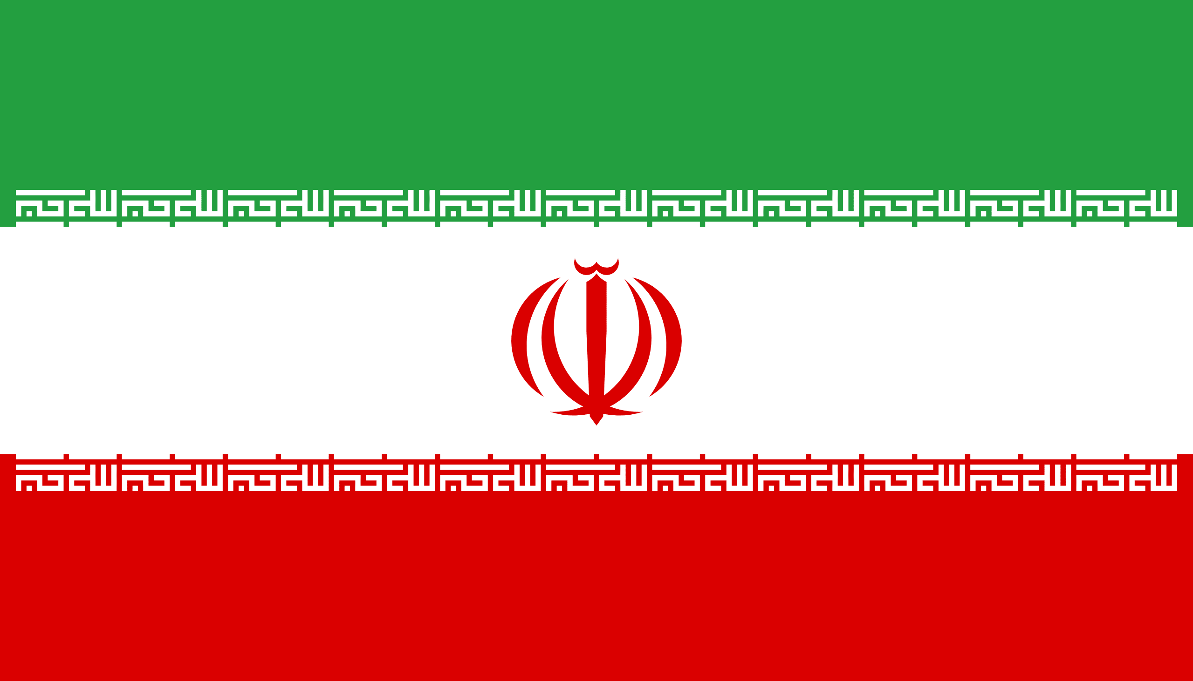
Country:Iran
Committee:Comission on the Status of Women
Topic: Enhance Gender Equality in New Normal
Delegate:Rümeysa SAĞLIK

Unfortunately, gender inequality has reached the top global issue in the World. Many women lack adequate to healthcare and less represented in political sides, are affected by gender-based violance, face discriminatioin the workplace, and lack equal access to education.Also in their work-life people who are men choose responsibility for their gender and give females fewer rights to talk.Including religion religion, people can also seperate human being by looking at their sex.For instance, a woman’s educational career or business is affected by a pregnancy, household work, Access to opportunities at school or office and the danger of physical or sexual assaults.

As statesmen die in Iran, new ones take over the government. The government system is also renewed. New dignitaries remove or add new restrictions on women. Most heads of state who head government pass new laws or amend existing ones to protect gender equality. Especially during the last three governments, many rights and freedoms have given to women: right to vote, right to education, equal salaries for men and women, and the right to hold public office.

According to the 2017-2018 Women, Peace and Security (WPS) Index, Iran was ranked 116th out of 153 countries in terms of legal discrimination. The World Bank's database "Women, Business, and the Law" lists 23 restrictions on married women in Iranian law; this includes "applying for a passport, going abroad, choosing where to live, and being the head of the household. Women cannot find a job, cannot have a profession like a man, and cannot be guaranteed equal pay." There are no laws that would restrict gender discrimination in equal employment and employment."

In order to raise new generations who will respect people regardless of their gender, and for women to lead a more comfortable life, the current government needs to support women's aid funds, regulate the constitution, establish women's empowerment working groups to provide social support to women, and emergency centers to meet all kinds of needs of women.

