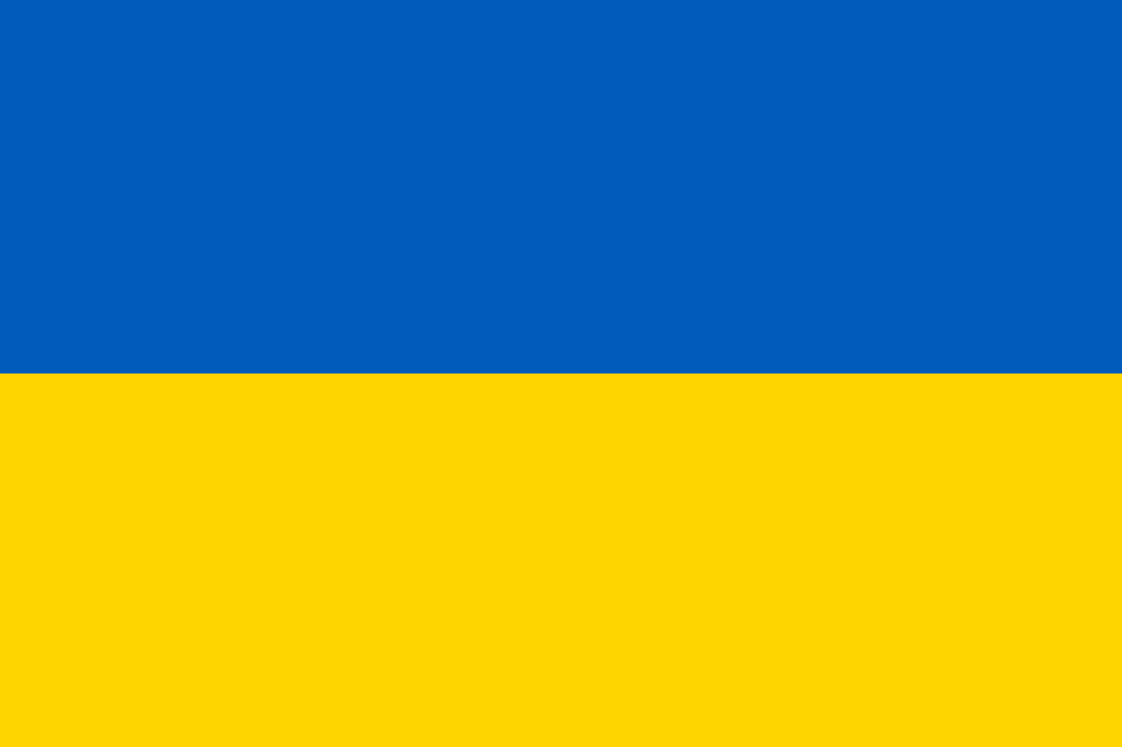

Country: Ukraine
Committee: Disarmament and International Security
Topic: The Status of Donbas region and Oppression on Donetsk and Luhansk
Delegate: Batuhan AZELOĞLU, Sırrı Yırcalı Anatolian High School
Since the outbreak of Crimean Tragedy, the bilateral relationships of Ukraine and Russia have continuously declined. The clandestine espionage activities of Russia unfortunately led to the interminable atrocities which manifestly engendered much casualty either on the civilian side, or on the military side. Even today, our glorious nation is ineluctably subject to traumatic conflicts, in particular, in the East of its borders.
When the imminent war erupted, the astounding landscapes of our country has been buried under the stale air of the Russian president’s virulent hatred; as a sovereign nation whose borders are unarguably and inconditionally indivisible and inviolable, we would undoubtedly act in self-defence. Thus, we are not liable to a sanction for national armament and Russian casualties.
In spite of the unacknowledged and unrecognised referendum held on March 16 of 2014, multitudinous surveys conducted in Crimean region have manifestly proven the dismal dolor and the irremediable anguish, which have been inflicted upon them ever since. Therefore it refutes the misrepresented will of the Crimeans to remain under Russian jurisdiction; it requires an international intervention to liberate the local residents from the yoke of the Russian Federation.
Following the first two unalterable articles of our constitution—Ukraine is a sovereign and independent, social, law-based state; the sovereignity of Ukraine extends throughout its entire territory; Ukraine is a unitary state; The territory of Ukraine, within its border, is indivisible and inviolable.—, we cannot be expected to make a compromise concerning our borders. Subsequently, the Ukrainian government doesn’t recognize the independence of Luhansk and Donetsk.
Ukraine requires a total cession of Luhansk and Donetsk. Furthermore, the establishment of no man’s land or a buffer zone between both states to prevent future disputes would certainly be appreciated by the Ukrainian presidency. Although, the plenipotentiary has the right to propound another resembling proposal. In any case, Donbass region will not be ceded to Russia.
As the consequence of the Russian invasion, Ukraine will stand firmly by siding with the Western Bloc. One of the indispensable draught bills, which will be advocated for in the most intransigeant way, is the NATO membership of Ukraine.
—Though we have a patriotic population, who will defend their land to death; the health, sanity and education of our children constitute a considerable counterpoise in this ‘bellicose’ equation; I, as the president of the Ukrainian republic, consent to compromises for a definitive peace to this full-fledged war. — states Mister President Zelensky as an epilogue for the position paper.

