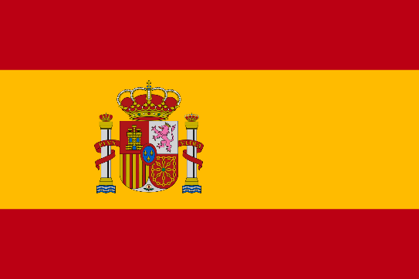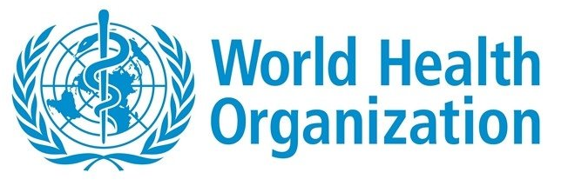
ASSUMING CONTROL AGAINST POSSIBLE FUTURE PANDEMICS AND COVID-19 VARIANTS
COMMITTEE: WORLD HEALTH ORGANIZATION (WHO)
COUNTRY: SPAIN
DELEGATE: SUDENAZ BAYRAKDAR
SPAIN AND WHO
Spain is the third-largest country in western Europe. The Spanish mainland is bordered by France on the north and Portugal on the west side. Global health indicators in Spain have been improving steadily since the 1970s. The average life expectancy is one of the highest in the world and mortality rates have been decreasing since the mid-1970s to reach a rate very similar to EU average levels. The top three causes of death in Spain since 1970 have been cardiovascular diseases, cancer, and respiratory diseases.
COVID-19 IN SPAIN
the first case in Spain was observed on January 31, 2020. the person who knew about this first case was a German tourist. Spain, which entered full quarantine on March 14, 2020, with the first death observed on February 13, is the 2nd in Europe with the number of cases exceeding half a million. the country became.
VACCİNATION IN SPAIN
As of September 2021, Spain is one of the countries with the highest percentage of its population vaccinated. of course, this was almost a successful end with the closure of borders, the cessation of flights, and the strict implementation of masks, social distancing, and hygiene rules for Spain.
COVID-19 SUPPORTING
Covid-19 pandemics had become really detrimental to the public as financial. So in Spain state made lots of help and supporting to them to relax them in this constrained situation

