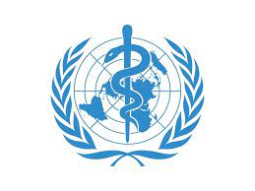
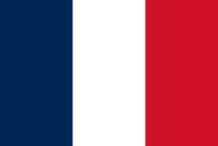
ASSUMİNG CONTROL AGAİNST POSSİBLE FUTURE PANDEMİCS AND COVİD 19 VARİANTS

COUNTRY: FRANCE
COMMİTTEE: WHO
THE PARTNERSHİP BETWEEN WHO AND FRANCE
As the delegate of France, we would like to say that our main aim is to improve public health and international health security. That is why, in coordination with our partners, we have developed a fruitful strategic partnership with the WORLD HEALTH ORGANİZATİON. We are supporting the actions of WHO, which is central and vital to a global and coordinated response to the pandemic.
Our country, a major global health player, supports the WHO’s role of global health coordinator and contributes more than 500 million € a year. We are one of the WHO’s main contributors, 12th-largest contributor to the WHO budget.
COVİD 19 İN FRANCE
France was the first country with covid cases outside Asia, the first among other countries with the highest mortality rate and one of the European countries hardest hit by covid 19. Due to the pandemic, we lost more than 145 thousand people and we are aware of the fact that we need to protect our citizens from covid, other covid variants and possible future pandemics.
As the delegate of France, we are strongly supporting vaccination not only for our own country but for the whole world. Currently about 80 percent of the population is vaccinated. This rate continues to rise from day to day but this won’t be enough cause of covid’s variants. We are aware that the current vaccines can still provide protection from new variants but no one can give a guarantee that the vaccines can provide possible future variants. As France we believe that the solution to these problems could be a financing fund for countries that are underdeveloped in vaccine.

