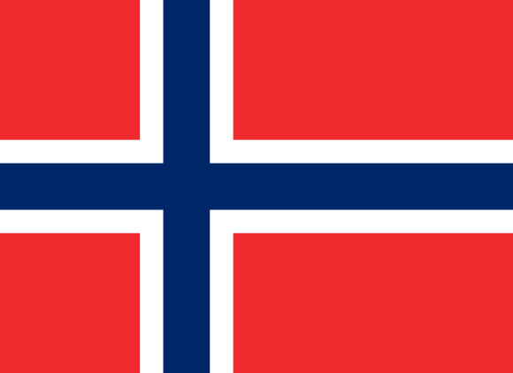
Country: Norway
Committe: World Tourism Organization (UNWTO)
Delegate: Dilara DİKME
Topic: The effects of current problems on tourism

We all know it’s hard to get a visa for Europe. I can say firsthand that, as with all European countries, Norway is very strict about this. Norway ranks first among the countries with the highest per capita income and is the country most likely to be emigrated by foreigners. Therefore, Norwegian immigration policies have become more stringent. Norway is not a country that generates a great income from tourism. So, unrealistic visa requests are unlikely to be accepted.
Travel and tourism in Norway generated roughly 4.6 percent of the country domestic product. Annual tourist consumption expenditures in Norway have increased to around 194 billion kronor by 2019, this process has been disturped due to the pandemic period. The country has seen the lowest figures compared to other European countries. Norway's sparse population and cold climate have set it apart from the rest of Europe, so it is different from other European countries.
Norway may try to expand its rules to stop stalling in tourism sector but the policy they’ve been pursuing all this time shows they won’t change. Their economies will not suffer from this decline.

