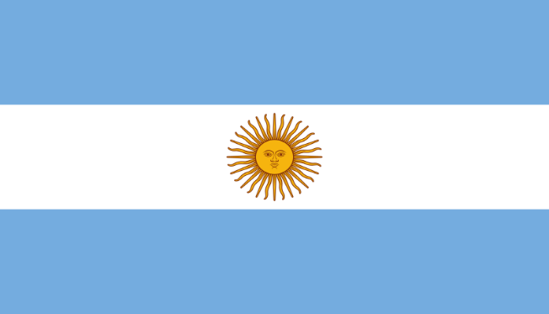
Delegate : Eylül Bozkır
Country : Argentina
Committee : UNWTO

Argentina has become one of the fastest growing countries in tourism in recent years. The Argentina Republic is considered as the third most visited country in South America and the fifth most visited country in all of Latin America. It’s a favorite tourism center of many foreigners due to its vast lands, diversity of climatic behaviors and natural wonders it possesses. Argentina is a country that has shown remarkable growth in it exports. National tourism is a Pioneer in the development of hotels and tourist attractions. One of the biggest features for tourism in Argentina is the variety of climates it can offer, which is a point favor of tourists depending on the taste of each person.

The first steps of tourism in Argentina appeared in the nineteenth century, when at the end of 1886 the railroad reached Mar del Plata, and years later a major tourist activity began that would stretch along the coast with the birth of Miramar. Mar de Plata was the first resort frequented by the country's elite, with beaches, sports activities such as golf and tennis, and a wide variety of tourist opportunities such as horse riding. By 1910, the appearance of the first European immigrants with a lower social class than the one who visited here began to appear. Later, in the 30s, the spa towns of Villa Gesell, San Clemente and Mar de Ajo were created, thus embarking on the project to transform Mar del Plata into a major tourist destination. At that time, travel agencies started offering tourist packages at affordable prices including tickets plus accommodation, which fueled the growth of tourism in that part of Argentina. In 1947, horizontal property law was passed that allowed the construction of buildings, public works, and new rights to workers such as paid leave, making Mar del Plata a mass destination and forcing the elite to seek new directions. In the mid-50s, the first International Film Festival was held in the town of Mar del Plata, but the proposal did not achieve its goal of making the place a destination for international tourists. Some of the 60s and 70s represented a low blow for tourism in Mar del Plata. A military coup and the enactment of new economic policies have negatively affected local tourism, and the number of visitors to the resort, which has become a luxury destination that is hardly accessible to tourists, has declined sharply. However, tourism in Argentina started to show a slight rise in the 80s, despite the return of democracy to the country and the unstable economic situation recorded at the time.

But if we talk in terms of today, things are not going as well as they used to in Argentine tourism. Argentina has experienced an annual average inflation of 105% since a century ago and had to change its currency 5 times. Also, during the pandemic that started in 2020, the number of tourists has drastically decreased and the country has been under the influence of high inflation and devaluation since 2021. Argentina is a country accustomed to economic crisis and these economic problems affect tourism the most. We know that Argentina is currently trying to increase its tourism revenues, in our opinion, we should work on the Argentine economy to accelerate this process and keep the economy away from bad explosions.

Bibliography:
https://www.indyturk.com/node/384276/t%C3%BCrki%CC%87yeden-sesler/arjantin-ekonomik-krizi-enflasyon-ile-deval%C3%BCasyonun-bitmeyen-tangosu
https://descubrir.online/tr/turismo-en-argentina/
https://ticaret.gov.tr/data/5eff169d13b87612f80cb8c9/Arjantin%20%C3%9Clke%20Profili.pdf

