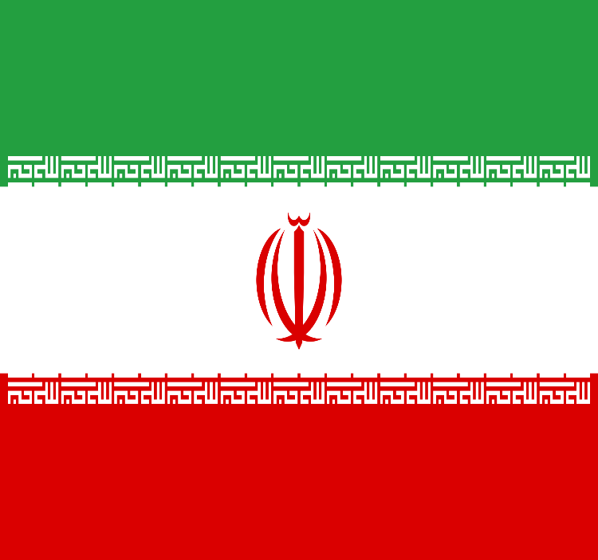
Delegate: Defne ÇOBAN
Committee: United Nations Security Council (UNSC)
Country: Iran
Topics: The Nuclear Program Of Iran And Weapons
Of Mass Destruction

Nuclear weapons had been a part of many country’s security systems since WWII. Even so these weapons are highly dangerous for both our planet and us people who lives on it. Nuclear bombs are the most powerful weapon ever created, and today there are enough in military arsenals to kill every living thing on the planet several times over. They were first tested and used in WWII and no country used them since. But still many countries owns nuclear weapons for their security. Besides being a part of those countries who owns nuclear bombs Iran also has a special program for nuclear weapons. This program was launched in the 1950’s with the help of the United States under the Atoms for Peace program. Atoms for Peace program is a program made by U.S to supply equipment and information to schools, hospitals, and research institutions within the U.S. and throughout the world. On 5 March 1957, a "proposed agreement for cooperation in research in the peaceful uses of atomic energy" was announced under the Eisenhower administration's Atoms for Peace program. In 1970 Iran had to sign the Non-Proliferation Treaty (NPT) and limit the use of nuclear energy to peaceful use. They also had to put their use of nuclear weapons under the International Atomic Energy Agency (IAEA). Right now Iran is currently possesing weapons of mass destruction (WMD) and has signed treaties repudiating the possession of WMDs including the Biological Weapons Convention, the Chemical Weapons Convention, and the Non-Proliferation Treaty. Iran has first-hand knowledge of WMD effects.

In the 1950’s the U.S helped Iran to create the nuclear program. The nuclear program of Iran is an ongoing scientific effort by Iran to research nuclear technology and allegedly develop nuclear weapons. With this program Iran was able to use the nuclear power. Iran's first nuclear power plant, the Bushehr I reactor, was completed with major assistance from the Russian government agency in 2011. In 1970 the Non-Proliferation Treaty (NPT) limited Iran’s use of nuclear power to peaceful use, and made its nuclear program subject to inspection by the International Atomic Energy Agency (IAEA). After Iran stopped cooperating with the West after the revalution it countinued the program in secret. But in the 2000’s the revelation of Iran's clandestine uranium enrichment program was found and it made people assume that the program may not be for peacefull uses. The IAEA launched an investigation in 2003 after an Iranian dissident group revealed undeclared nuclear activities carried out by Iran. In 2003 the United Nations Security Council suspended this program. In november 2011 IAEA stated that Iran has been doing experiments to make a nuclear bomb. However in 2015 the organisation said that no evidence was found. In 2015 the IAEA certified that Iran was still abiding by the international Joint Comprehensive Plan of Action of 2015. But in july 2015 IAEA again said that Iran disobeyed the Non-Proliferation Treaty (NPT).
Until 2021 Iran always insisted that its nuclear programme was for peaceful purposes, and there was even a fatwa by Ayatollah Khamenei against producing nuclear weapons. But in an interview in November 2021, on the anniversary of the assassination of Mohsen Fakhrizadeh, a former head of the Iranian Atomic Energy Organization mentioned the country's growth "involving satellites, missiles, and nuclear weapons" and said that although Iran's stance on nuclear weapons being haram was quite clear, Fakhrizadeh had "created this system".

We think that nuclear weapons are highly dangerous products and we musn’t use them even in wars. They make huge damages to the environment and the people who live in that enviroment when they are used. And that does notmake any exceptions. Nuclear weapons may have been used years ago but a lot of countires still has a high amount of them. For security or not nuclear weapons should not be used or made.

