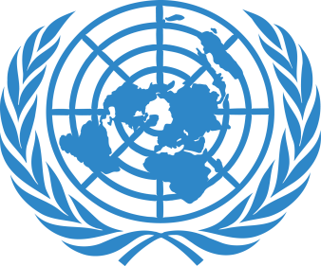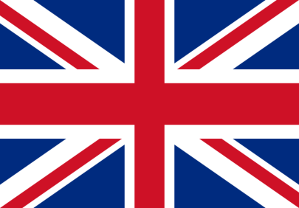

Country: United Kingdom
Committee: DISEC
Topic: The status of Donbas region and oppression of Russia Federation and Ukraine on Donetsk and Luhansk
Delegate: Ataberk Küçük

We would like to express that we are sorry and do not support these conflicts since President Yanukovych rejected Europan Association Agreement. The necessary military aid and poitical support has been provided to Ukraine in the conflicts in the Donbas region and Crimea, which has been going on since 2014, and it continues today.
As a result of the riots that started after the Association Agreement with Europe, which was rejected by the 4th president of President of Ukrain Viktor Yanukhovych was dismissed by the Parliament and fled to Russia. After the fall of the Yanukhovych government, Ukrainians of Russian origin revolted against the new government. Russia Federation annexed Crimea. Thus, the events spread to an international dimension. After the annexation of Crimea by the Russians, uprisings began in cities where people of Russian ethnic origin lived, such as Odessa, Kharkiv, Donetsk and Luhansk. The riots led to clashes in the Russian-dominated Ukraine's Donbass region. The insurgents quickly seized government buildings and declared that they had established the Donetsk and Luhansk People's Republics. Frozen conflicts and an active invasion stil ongoing in Ukrainian territories.
Like all other countries we don’t support war but it doesn’t mean they can’t fight for their freedom and their country. Ukrainian Armed Forces have a good firepower with our military aids and donations. We hope these conflicts in Donbas region and Ukraine will end as soon as possible with peace.

