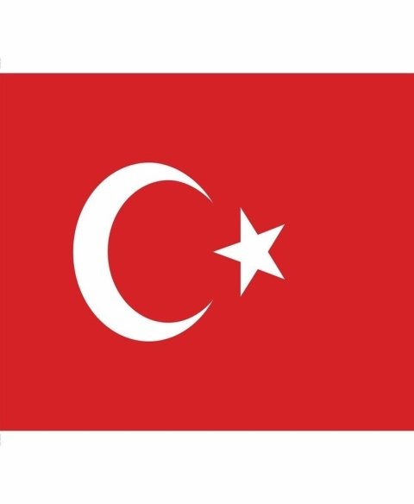
Conference : RKAL Model UN Committee : United Nations High
Commissioner for RefugeesTopic : In terms of ending discrimination against refugees and their transition
Country : Turkey
Delege : Merve Dikeç

Position Paper
Turkey became a party to the 1951 Convention Relating to the Legal Status of Refugees with the annotation of "geographical reservation" in 1961, and joined the New York Protocol of 1967, which expanded the scope of the convention, in 1968. As of March 17, 2022, the number of Syrians under "temporary protection" in Turkey is 3,751,889 people, constituting the largest group among more than 4 million foreign nationals in Turkey. This makes Turkey the country hosting the highest number of refugees in the World.

For Turkey, which has such a large number of refugees, the safety and well-being of those people is also very important for the country. Turkey is doing its best on this issue and has many aid organizations which have already help this people . In this conference we want to develop ideas about the refugges problem and their safety .

We want to pass laws about refugees and defend their rights . We hope that they transfer their difficulties to other countries and provide their best assistance in this regard in other countries. We believe we can offer the refugges a better lives .

