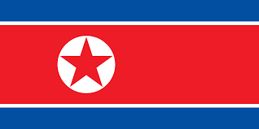 The Coronavirus and Its Variants 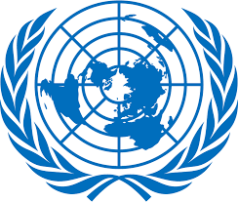
That Emerged in Wuhan, People’s Republic of China

Country : Democratic People’s Republic Of Korea
Committee: The World Health Organization(WHO)
Delegate: Ömer Faruk Erişen

Since January 2020, We have been taking strict and comprehensive measures to protect our country from the COVID-19 epidemic in our country which has borders with People’s Republic of China.
For instance, We set up quarantine facilities and imposed strict travel restrictions. And We should point out that these measures have achieved their purpose and faciliated our fight against the virus.

We should point out that we didn’t detect any cases in our country. Therefore We don’t verify anykind of news or rumor about our COVID-19 case statistics. We are the one of the first countries to close our borders to due to COVID-19. Started from 23 January, We banned foreign tourists and all flights in and out of the country were halted. Our authorities began quarantining suspected flu and cold cases for two weeks. On January 30, We declared a “state emergency” and set up esteblisment of anti-epidemic headquarters around the country.
In early February, We took severe measures to block the spread of COVID-19. We suspended all international flights and railway services, and we largely closed connection by the sea and road over the following weeks. We made it obligatory to wear a face mask. We forbidden visiting public places and canceled public events.
In late February, We announced that we would close our borders until a cure was found. We also started to put everyone who enters the country under medical supervision in February. We closed our schools on 20 February. We started to perform disinfection activities, including placing imported products in quarantine.
We subjected our citizens returning from other countries to a 40-days isolation period to which was added a 30-days “medical observation” period.
On 14 March, We reported there were still no cases in our territory. We started to construct new hospitals new hospitals for increase our quality of health service.
We took health support and test kits from Russian government, WHO, International Federation of Red Cross and Red Crescent Societies, U.S. State Department and South Korean Government. In March, We increased the old 14-days quarantine time to 30 days and We evacuated the diplomats and all foreigners in our country to Vladivostok.
In late March, The measures we have taken in the face of the pandemic have been largely successful.
From mid to late April, We eased the restrictions on the foreigners who were travelling. We closed temporarily the British Embassy from 27 May and all diplomatic stuff left the country. This was due to restrictions on entry the country. On June 19, We opened all educational institutions.
In March 2021, We decided not to participate in the 2020 Summer Olympics in Tokyo. As a result, the Olympic Committee of the Democratic People’s Republic of Korea was suspended by the International Olympic Committee(IOC) through the end of 2022.
In July 2021, We rejected shipments around 2 million doses of Oxford-AstraZeneca vaccine couse of possible side effects. The same month, Russia offered to supply our country wiyh its own Sputnik V vaccine on multiple occasions.
In January 2022, the first freight trains between our country and the People’s Republic of China resumed after a two year hold.

