Country: United States of America | 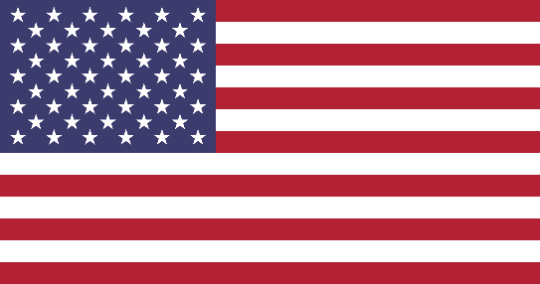
Committee: United Nations Security Council (UNSC)
Topic: Nuclear Disarmament and International Security
Delegate: Nil Battal
Nuclear weapons are the deadliest weapons on earth. An entire city can be destroyed with just one nuclear bomb. Potentially kill millions of people and endanger the natural environment and lives of future generations due to its long-term effects. The dangers of nuclear weapons arise from their existence. Although nuclear weapons were used only twice in war (in the bombings of Hiroshima and Nagasaki in 1945) there are still over 13,000 of them left in our world today. More than 2,000 nuclear tests have been carried out to date. Disarmament is the best defense against such dangers, but achieving this goal is an extremely difficult challenge.
Nuclear Weapon Free Zones (NWFZ) was established to strengthen global standards for nuclear non-proliferation and disarmament and strengthen international efforts for peace and security. The United States is deeply grateful for your leadership of the Conference on Disarmament during this difficult time. Today I stand to speak about the position of the United States on nuclear disarmament. The recent situation between Russia and Ukraine is an immediate example of why transparency, risk reduction, and crisis management mechanisms - all of which the United States has always wanted - are essential to international peace and security.
The United States stands by this statement and will continue to support dialogue and negotiations to reduce nuclear risks as well as limit nuclear weapons. A situation like this is precisely why practical work to promote security, nuclear non-proliferation, and disarmament is needed. Now is the time for world leaders to speak out clearly against nuclear weapons, as the United States we are ready to lead nuclear disarmament with the support and cooperation of all members of the United Nations. But we need more than talk, we need concrete actions to make the international community safer.
We sign the following immediate actions and call on all Member States:
- Affirm that nuclear war cannot be won and should never be waged, and therefore nuclear-weapon states should withdraw their nuclear forces and affirm the policy of never starting a nuclear war.
- Committed to eliminating nuclear weapons by 2045.
- Reduce nuclear weapons budgets, end investment in the nuclear weapons industry, and redirect investments and budgets to support the United Nations.
Thank you, President, for allowing me to take the floor.

