Application Person: Nil Betül TÜLEK
Conference Name: BESTMUN’22
Committee Name: Israel-Palestine Conflict (Finland)
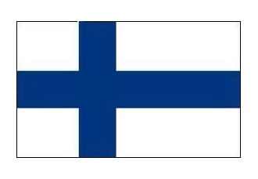
FİNLAND
Finland officially the Republic of Finland
Finland is a Nordic country and a member state of the European Union in Northern Europe. It shares land borders with Sweden to the west, Russia to the east, Helsinki is the country's capital and largest city,.It has a population of more than one million. Helsinki is the world's northernmost metropolitan area and the northernmost capital of the European Union. Finland is bilingual, with Finnish and Swedish being official. The climate varies relative to latitude, from the southern humid continental climate to the northern boreal climate.
Natural conditions in the northern part of Finland greatly restrict agriculture. Finland is a world leader in the high-end electronics industry. It has advanced metal and engineering sector and high-tech forest industries. Nokia company is located in Helsinki. Nokia has been the world's third largest manufacturer of network equipment since 2018.This had a very good effect on the economy of Finland.
İsrael Palestine Conflict
For centuries, Jews have been in various parts of the world without an official country.
Due to various difficulties, they went in search of a state. They organized a council in Tel-Aviv.
It has been announced of the Jewish National Council meeting in Tel-Aviv on May 14, 1948. It borders the Palestinian territories Gaza and West Bank.With the Palestine Sharing Plan prepared by the United Nations in 1947, the establishment of an international Jerusalem administration in the region was requested. At the end of the 1948 Arab-Israeli War, Israel retained most of the former Palestinian territories. Efforts to end the Palestinian-Israeli conflict still have not led to a final peace agreement.
The Palestinian people cannot come to terms with the state of Israel in order to return to their former borders. There are frequent conflicts between Israel and Palestine that result in loss of life.
Many options have been presented for the Israeli and Palestinian problem. We, as Finland, invite the parties to common sense. We suggest that they find an unarmed solution with the mediation of the United Nations.

