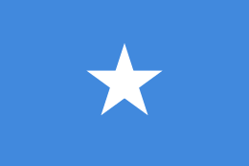 Israel – Palestine Conflict 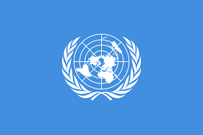
Country: Federal Government of Somalia
Committee: DISEC
Topic: Israel – Palestine Conflict
Delegate: Eyüp Anıl Turunç
The Republic of Somalia was formed in 1960 by the federation of a former Italian colony and a British protectorate. Somalia is bounded by the Gulf of Aden to the north, by the Indian Ocean to the east, by Kenya and Ethiopia to the west, and by Djibouti to the northwest. Mogadishu is the capital of Somalia.
92.4% of the population is formed of Somalians and the rest consists of Arabs, Afars and others.
Besides the Somalia language, Arabic is the second official language of the country.
Owing to Somalia’s colonial past, many people have a good command of English and Italian.
All Somali belongs to the Shāfiʿī rite of the Sunni sect of Islam. 1,0 % of the population believes in other religions.
Somalia does not and has never had formal diplomatic ties with Israel, a principled position it shares with many other Muslim governments. For Somalia prospects are complicated by the limited role Israel played during the Cold War in East Africa.
Israel has always wanted to build strong ties with African countries since the time of Herltz and during the following leaders. They supported that both Jews and Africans had the same unfortunate fate as discrimination, oppression, slavery, torment and degradation.
However, before Israel became affective in African lands, the Arab league, which we as Federate of Somalia is the eighth member, was founded and Israel lost the opportunity to get those strong ties it wished. Nevertheless, Somalia’s border neighbour Ethiopia has made a close relationship with İsrael because of the Falasha group inside it. We as a 98 percent of Muslim population has never approved this relation. Rather we had ties with Egypt and The Soviet Union mostly which interfered with African issues in the post-colonial period of Africa.
After the war Somalia had with Ethiopia our attitude towards Israel has cleared even more. We have never been on the side of Israel. Israel has claimed that he is against the apartheid regime practiced over African locals of the Republic of South Africa. However, now it is the same even worse oppression they are showing on Palestinians in their own homeland.
Thus, we as Federate Government of Somalia has condemned Trump’s decision to move the US embassy to Jerusalem and supported the Palestinian struggle for their rights with the protests in Mogadishu which followed Trump’s decision.
We as the Federate Government of Somalia see the resolution of Israel – Palestine conflict in Israel’s giving up its violation, invasion and exiling over Palestinian nation and obeying the international law and applying human rights as well as turning back to its borders given by the UN in 1948 and allowing the expelled Palestinians to return their homes.

