Country: The United Kingdom
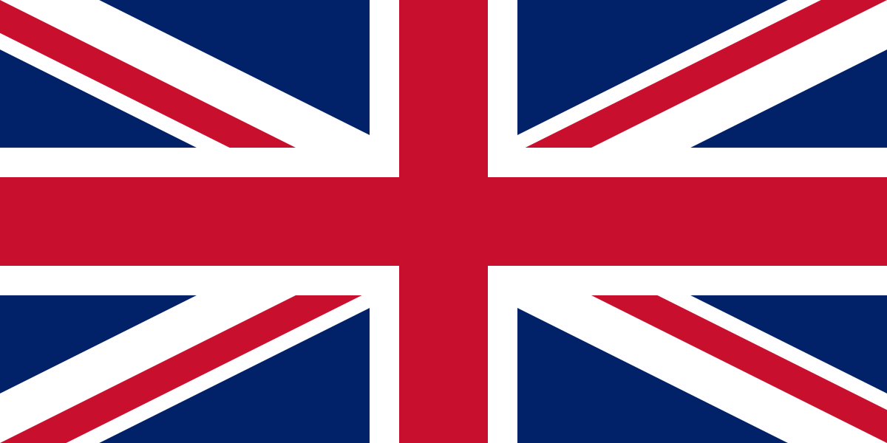

Committee: UNESCO-1 (UNITED NATIONS EDUCATIONAL, SCIENTIFIC AND CULTURAL ORGANIZATION)

Agenda Item: Barriers to Education in Conflict-Affected Countries

The United Kingdom comprises the whole of the island of Great Britain, according to us news united kingdom has the second place and it has a GDP of $2.88 trillion and GDP of 43,070 per capita but Data from the Smoking, Drinking and Drug Usage among Young People in 2016 showed nearly a fifth (18%) of pupils said that they had taken drugs in the last years.

We got a break through, we stated many things like the new photocopy machine, and because of that, and we photocopied books and learning materials. We discovered that the world is not flat by traveling the whole world in a circle and many more things, as every country we entered wars, which were throwbacks for us.

But as time passed by we entered WW2 (World War 2) we and all the world’s children went to In the United Kingdom, boys of 17 were accepted into the Home Guard when it was formed in 1940 in preparation for a German invasion and as a last line of defense. On 27 September 1942, the minimum age was lowered to 16, which was a setback to their Education.

The most significant thing in the United Kingdom after WW2 (World War 2) education act of 1944, which raised the compulsory leaving, age of 15 years old, and made secondary education freely available to all after 1944 in 1945 UNESCO was funded by London which was a huge investment in to it. From this, in 1945, a UN Conference for the establishment of an educational and cultural organization was convened in London to establish the intellectual and moral solidarity of mankind.

As the delegation of United Kingdom, we think United Kingdom must and will have good diplomacy withe other counters and the government must support people about education. Inc. reassign the economic activities would be a good solution too.

