Country: Norway
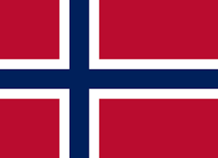
Committee: UNESCO-2
Agenda Item: Barriers to Education in Conflict-Affected Countries

Norway is an independent kingdom in the far north of Western Europe, containing the north and west of the Scandinavian Peninsula. Neighbouring Finland, Sweden and the Russian Federation, the country borders the Norwegian Sea, a branch of the Atlantic Ocean to the West.
Norway also has one of the best education system.10 years of education is compulsory in Norway.They think that every children must receive an education. But because of the wars in the world, some children don't get enough education. 28 million children are now victims of the war in the world.
Norway seeks to protect and support children as much as possible who are victims of wars around the world. Norway supports govermental organisations working in this field, arguing that the right of receiving an education of every child must be protected. It is necessary to reach more children ,to make more donations aiming to help them to become well-educated people and to ensure that we have a world that everybody can live peacefully

