Country: Russian Federation
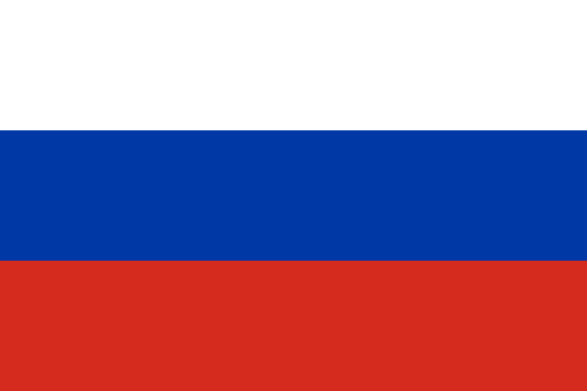
Committee: UNESCO-1
Agenda Item: Barriers to Education in Conflict-Affected Countries

Russian Federation is the biggest country in the world. It is located in Eastern Europe and northern Asia. It also contains Europe’s longest river and largest Lake Ladogo. Also World’s deepest lake, Lake Baikal. Russia was known as Union of Soviet Socialist Republic until the dissolution of the Soviet Union in 1991. It has one of the coldest climate, it has a wide variety of sources which leads natural gas. Its capital is Moscow which involves Gremlin Palace. Russia has some well-known authors such as Leo Tolstoy, Dostoyevsky etc.
Russia also has one of the best education system. Education in Russia includes several stages:
Pre-school education, Pre-school education is a first stage in the system of education which is represented by crèches and kindergartens,
General secondary education, According to the law of the Russian Federation, general secondary education includes:
Primary general secondary education (from 6 to 10 years of age, 1-4 grades),
Basic general secondary education (from 10 to 15 years of age, 5-9 grades),
Complete general secondary education (from 15 to 17years of age, 10-11 grades),
Vocational education, after school children in Russia have a wide choice of educational institutions where they can obtain vocational education, whose aim is to train qualified workers. Higher education, In Russia, there is a 3-level higher education, Baccalaureate (4years), Specialist (5 years), Magistr (6 years).

But during the Ukraine War, some of the acts that banning Russian arts or books decreases the education level, culture also the knowledge about history. War effects the economy so it might be hard for families to send their kids to school.
As Russian delegation, we think Russia must have good diplomacy with other countries and government must support people about education. Increasing the economic activities would be a good solution too. As Russian delegation, we remind that education is one of the most important human right and government must work on it.

