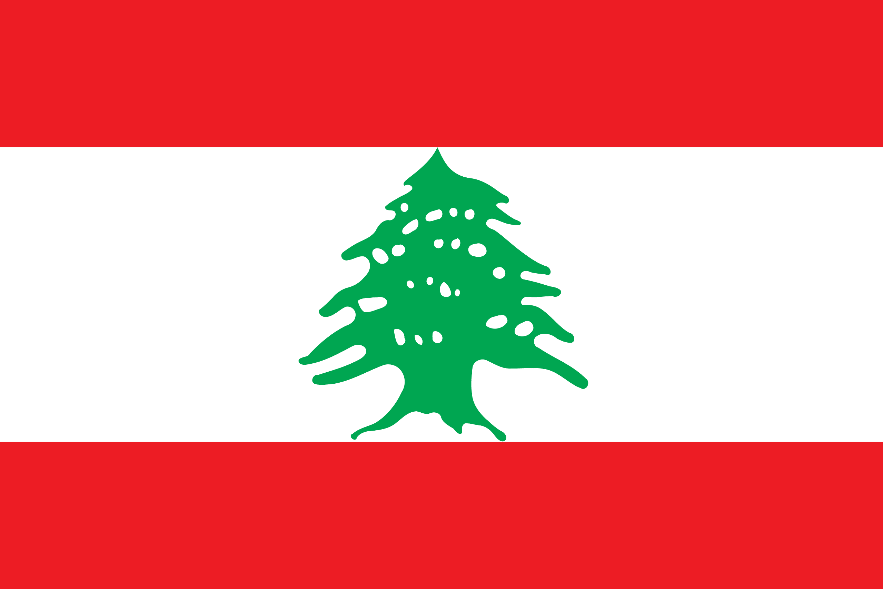
Country: Lebanon
Committee: UNHRC (United Nations Human Rights Council)
Agenda İtem: Refuge Crisis: Forcibly displaced and stateless people.

Lebanon is on the eastern coast of the Mediterranean, between Israel and Syria. It has an area of 10,452 km2. Today's Lebanon region is rich in cultural and religious diversity due to its location at the crossroads of three continents. Lebanon has been part of numerous successful empires. It was conquered by the Ottoman Empire in the 19th century and remained under its rule for the next 400 years. With the dissolution of the Ottoman Empire, Lebanon became a French mandate in 1920. Lebanon gained independence from France on November 22, 1943. In 1945, he became a founding member of the Arab League and later a member of the United Nations. The form of governance is parliamentary democracy. Since 1975, instability in neighboring countries has also negatively affected Lebanon's domestic political and economic situation. The resulting internal conflicts took place in 1978 and 1982. It took place in Saudi Arabia in 1989. The conflicts (civil war) ended with the Taif Agreement signed in October 1990. Its population is 6.8 million in 2020. The population growth rate is 2.6%. 67% of the population is between the ages of 15 and 65. Unemployment rose from 6% in 2019 to 6.6% in 2020. In Lebanon, where compulsory education is 6 years, schools are of three types: state, private and semi-private. Public schools, which account for half of the country's schools, are affiliated to the Ministry of National Education and education is free of charge. The total number of beds in lebanon is around 10,000, 8,700 in private hospitals and 1,300 in public hospitals.

Lebanon is home to more than 2 million Syrian refugees, in addition to 1 million refugees from Palestine and other nations. Housing, nutrition, education and health are among the problems experienced by migrants. As a result of the experience of Palestinian refugees coming to Lebanon and never returning, the policy of not establishing a refugee camp in Lebanon has been adopted and no official refugee camp has been established. Refugees have settled in Lebanon's poorest and most backward regions and neighborhoods across the country. As a result, the presence of refugees has exacerbated the already difficult living conditions of local communities. Lebanese employment opportunities are limited because Syrian refugees accept lower wages and longer working hours without any social benefits. This limited Lebanese employment opportunities in Lebanon, where employment conditions are not fully regulated, and the informal economy is widespread. With the arrival of refugees, rents in Lebanon have increased by 3-4 times, severely limiting the need for shelter. In addition, domestic prices of goods have also increased due to the change in supply and demand in the market The increase in the prices of basic goods and services has created the food problem. On the other hand, the majority of the arrivals are children in the primary and secondary education level. This is the basis of a problem in itself. We have a sufficient number of schools where children can be placed and the number of teachers who can teach our students is low. In addition, while a French and English-oriented education system is followed in Lebanon, it is very difficult to be successful in Syria because the language of instruction is Arabic. Another main problem of refugees is health. In Lebanon, where health care is paid for, both national and international NGOs (Non-Governmental Organizations) are trying to raise funds for the treatment and supply of medicines for refugees they can reach. However, apart from injuries and ordinary diseases, we cannot do anything about serious interventions or diseases that require long-term treatment.

Due to the instability and economic crisis caused by the civil wars, the forced migration of people to Lebanon due to the external wars around Lebanon, and Covid-19 have affected the country's economy very badly. As Lebanon, we would like to state that we are in great economic difficulty. The services provided by our education and health sector are very limited. The country's expenditures and foreign debt exceeded its revenues. According to unofficial data, the Lebanese pound has lost up to 90 percent of its value against the US dollar and inflation has increased by 700 percent. More than half of Lebanese live below the poverty line, according to a United Nations assessment report released on July 1st. We need efforts to reform and revive Lebanon's unstable economy. There is an urgent need for energy financing, food and drug supplements. Oil reserves cannot be searched due to the country's political crisis. We have oil reserves underground. It's important to evaluate that. We should hold a special conference for Lebanon, which is facing the world's biggest challenges without fuel, service, electricity, water, money. We call on everyone to be aware.
Resources:
https://www.mfa.gov.tr/lubnan-kunyesi.tr.mfa
https://en.wikipedia.org/wiki/Lebanon
https://www.amerikaninsesi.com/a/abd-lubnan

