Country: Canada
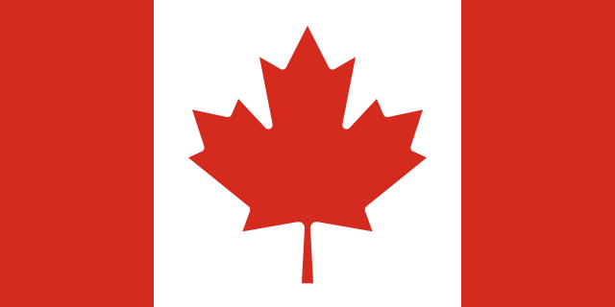
Committee: WHO (World Health Organization)
Agenda Item: New Normal after the Covid 19 Pandemic and the Role of Vaccination

Canada is a country in North America. It consists of ten states and three territories. Canada is bordered by Alaska in the west, and by twelve US states of the continental United States in the south. Canada is a federal parliamentary democracy and a constitutional monarchy, with Queen Elizabeth II being the head of state. Canada currently maintains strong ties with the UK as part of the commonwealth. The country is officially bilingual at the federal level. It is one of the world’s most ethnically diverse and multicultural nations. It gets a huge amount of immigration from many other countries. Its advanced economy is the eleventh largest in the world, relying mainly upon its abundant natural resources and well-developed international trade networks. Canada provides free health services to its citizens. Canadian Medicare provides coverage for approximately seventy percent of Canadians healthcare needs. The current population in Canada is thirty eight million. The life expectancy at birth is approximately eighty three. Canada’s largest trading partner and ally is the United States. Canada resembles the US in its market-oriented economic system, pattern of production, and high living standards. In the long-term, the Canada GDP per capita is projected to trend around forty four thousand and five hundred dollars. Canada has been active at the United Nations since its foundation in 1945
Covid-19 was confirmed to have reached Canada on January 25, 2020. Canada severely restricted its border access, barring travelers from all countries with some exceptions. For the first time in its legislative history, the act has been used, legally requiring all travelers returning to the country to self-isolate for 14 days, until rules were changed to accommodate fully vaccinated travelers. On September 23,2020, The Prime Minister of Canada declared that Canada was experiencing a “second wave” of Covid 19. New restrictions from provincial governments were put in place once again as cases increased, including variations of regional lockdowns. Near the end of summer 2021, cases began to surge across Canada, notably in the provinces of British Columbia, Alberta, Quebec and Ontario, particularly amongst the unvaccinated population. During this fourth wave of the virus, to pandemic restrictions such as mask mandates came like British Columbia and Albert. Due to the increase in cases, vaccination passports were brought to all states and all regions in Canada. On 11 August 2020, Russia announced the approval of its Sputnik V vaccine for emergency use. Approximately one year later on 23 August 2021, Pfizer-BioNTech vaccine was approved by USA. The vaccines that is accepted in Canada are: Moderna (including for children aged 6 to 11 years), Novavax, Pfizer-BioNTech (including for children aged 5 to 11 years), Sinopharm BIBP, Sinovac. Canada has the best vaccination rate among G7 countries. The %82,2 of Canada's population is fully vaccinated. Canada is a strong supporter of the COVAX Facility, which is part of the vaccines pillar of the ACT-Accelerator. The vaccines pillar aims to accelerate the development and manufacturing of COVID-19 vaccines, with the COVAX Facility as the global procurement tool. It unites over 190 economies to maximize buying power to support fair and equitable access to them for every country in the world. In December 2020, the Prime Minister announced that Canada would be sharing any vaccine doses in excess of Canada’s domestic needs with countries who needed them most. Since then, Canada has committed to donating the equivalent of at least 200 million doses to the COVAX Facility by the end of 2022.
Canada has supported the global effort to beat the pandemic from the very beginning. To date, Canada has mobilized more than $2.7 billion in international assistance in response to the COVID‑19 pandemic. Canada joined the ACT-Accelerator on May 4, 2020, and continues to be among its leading contributors. This global partnership ensures that people worldwide have equal and affordable access to COVID‑19 health products like: vaccines, tests for diagnosing COVID‑19, treatments, therapies and drugs (therapeutics). Canada is also working with international partners to address barriers to equitable access of vaccines by improving global capacity to manufacture them. Canada is expecting more financial aid from UN Nations and other countries.

