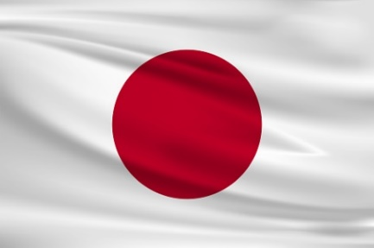
Country: Japan
Committee: Legality of Euthanasia in Japan
Topic: Legality of Euthanasia

In Japan, there are four types of euthanasia that they are legal. Active, Passive and different from other: Negative and pure euthanasia is legalized.
As Japan government, the euthanasia is totally legal. There are no any restrictions for it. It is first decided in Nagoya, 1962. It is free to people choosing their ways. Japan think the euthanasia as a death with dignity. It is seen as natural death. It is not judged by anyone.
Against some other perspectives, we think that it is not mercy ‘’killing’’. Because it is persons own decide within a lucid mind. The freedom of choice is on higher level than other countries that we legalized 4 euthanasias because we belive that if a human has right to live, it has right to die too. Also not just asking the patience, we ask the family members to learn some situations and to provide it.
Traditionally, Japanese doctors make most decisions without input or attention to request from patients, and giving them almost no info. That is because of the moral level. They often keep diagnosis secret for avoiding discouraging and depression.
The slippery slope of euthanasia is the people think that it is a murder. But it is the person’s own choice without any preassure. Also this procedure includes the psychiatrist’s supervising (Often). Meaning that it is not any other persons decide for the patient to live or die. To change people’s mind this arguments could be given.

Sources:
https://www.institute-of-mental-health.jp/thesis/pdf/thesis-03/thesis-03-08.pdf
https://www.shs-conferences.org/articles/shsconf/pdf/2014/07/shsconf_shw2012_00033.pdf

