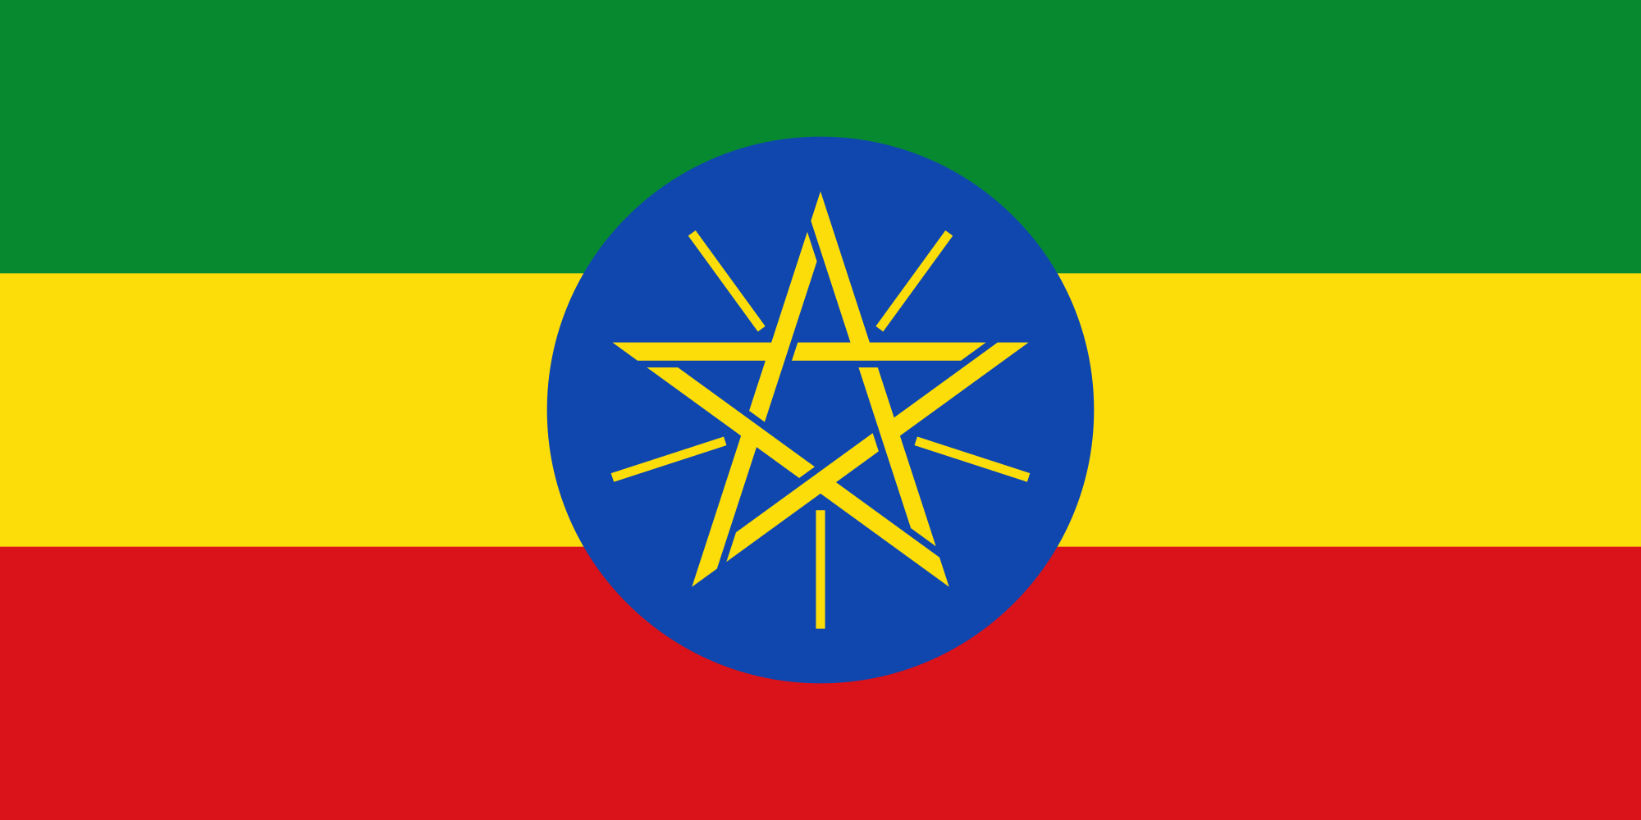 ISRAEL PALESTINE CONFLICT 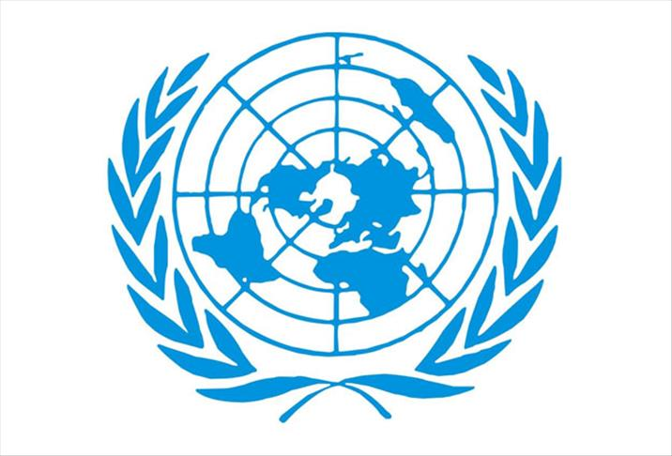
Country: Ethıopıan Federal Democratıc Republıc
Commite: DISEC
Delegate: Livanur Berk

It is a large eastern country located in the Horn of Africa. The capital of the country is Addis Ababa. It is the second largest country in Africa with a population of approximately 100,000 million people.. There are 64 different ethnic groups in Ethiopia. Ethiopia is one of the oldest countries in history. The other name of Ethiopia is "Abyssinia", which means land of slaves.

There are three theories about the origin of Ethiopian Jews. The origins of the Falashas go back to Menelik I, the sons of King Solomon of Jerusalem and Belkıs, queen of Thebes; They say that they belonged to the line of Dan, one of the sons of Jacob, and were called the lost tribe and went to Ethiopia, or the Babylonian I Exile or II. There are claims that Jews escaped from Egypt and settled in Ethiopia during the historical events known as an exile. B.C. When Christianity was defined as the official religion of the state in the 4th century, a group of Jews had to emigrate because they could not live their religion freely. The Jewish community that immigrated from Ethiopia to Israel wanted to maintain their own culture. Also, Falasha Jews differed from Israeli Jews in terms of religious rituals. There were disagreements between the Falashas and Israeli Jews. However, the Israeli administration wanted them to be assimilated and integrated into society. A significant part of this migration movement was organized by the state of Israel. For example, on May 25, 1991, close to 15,000 Falashas moved to Israel overnight. Within the framework of the 36-hour gigantic operation, 40 flights were made and 35 civilian and military aircraft were used. By placing 2-3 people on the seats, it was used up to the last limit of the capacity of the aircraft. Between 1977 and 1983, around six thousand Falasha reached Sudan and moved to Israel with covert air and sea operations. 1984 was a turning point. That year, about ten thousand Falashas set out for Israel. During this difficult journey, nearly four thousand of them died in refugee camps in Sudan from starvation and epidemic diseases. The remaining six thousand were transported to Israel by air in "Operation Moses" in November 1984. Seven years passed until 1991 when the population of Falasha left their village and congregated in Addis Ababa. In 1991, "Operation Solomon" transported 15,000 people to Israel overnight. Tens of thousands of Ethiopian Jews were brought to Israel, thus saving them from the civil war and famine in Ethiopia. The hunger and poverty experienced by the Falashas while living in Ethiopia increased their demand for military employment. On the other hand, against the Falashas, who served in the army to protect Israel, some of the fanatical Jews believe that the Falashas are not of Jewish ancestry and therefore cannot be real Jews. The US volunteers, on the other hand, aim to settle the entire Ethiopian Jewish Community in Israel. Ethiopian immigrants living in Israel do not think that the US and Israel pursue political interests. Those who see immigration from Ethiopia to Israel as the meaning of Zionism say that they support this immigration to protect Jews and that this is the purpose of Israel's existence. There is the opinion that the reason why the Jews in America are closely interested in Ethiopian Jews is not to repeat the mistakes made by the USA in history.

At the African Union Summit held in Addis Ababa, the capital of Ethiopia, it was stated that Israel's observer membership was suspended and the final decision on membership will be discussed at the summit to be held next year. The move was considered a "victory of the will of the people". The resolution was "consistent with the African Union's historical stance in supporting the Palestinian cause and opposing colonialism and apartheid".

