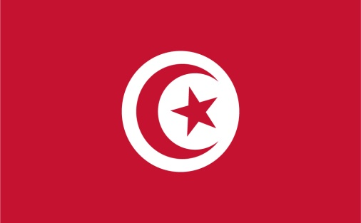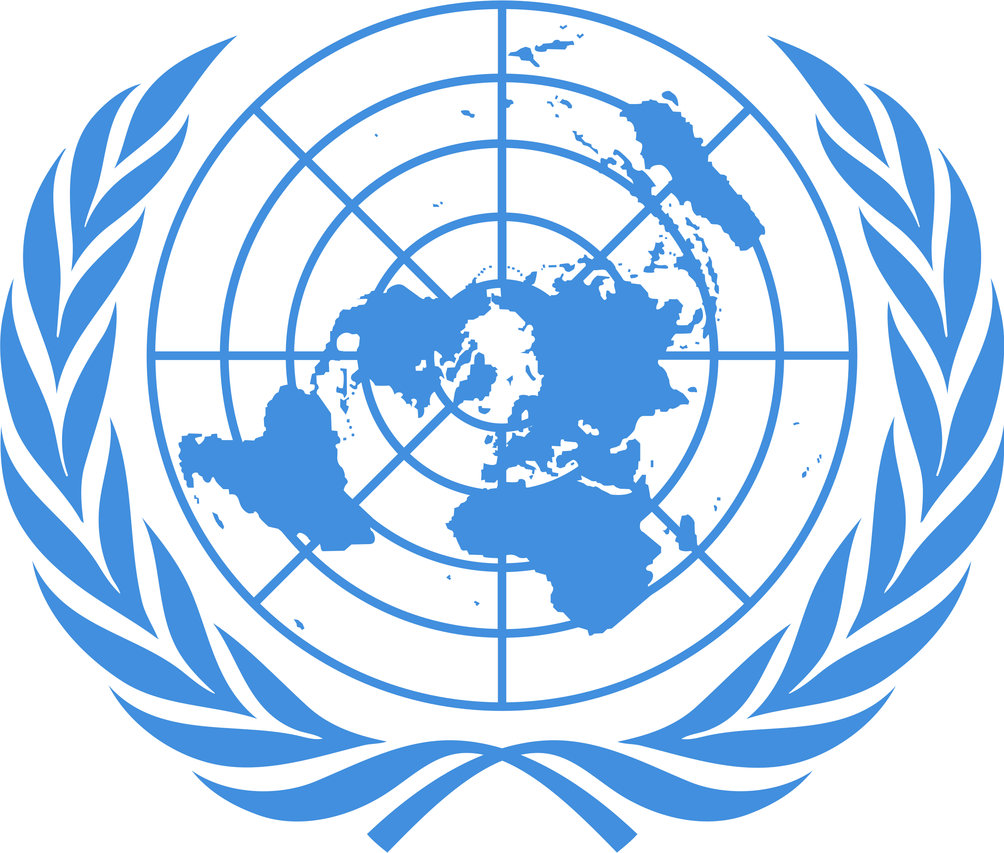

Country: Republic of Tunisia
Committee: DISEC
Topic: Israel – Palestine Conflict
Delegate: Yağmur Sağırkaya

The Israel and Palestine conflict has been going on for a long time which causes many problems worldwide, such as the violation of Palestinian people’s rights, ongoing wars in multiple places, and the current state of Jerusalem which is considered sacred to most religions. As the Republic of Tunisia, we are closely related to the topic and are not afraid of stating our position on this matter.

As the Republic of Tunisia, we are opposed to any form of war which leads us to the fact that Israel is using violent and cruel ways of dealing with the Jerusalem matter. As Palestine is also a member of the Arab League, the Republic of Tunisia recognizes Palestine as a country that has its deserved rights and terrain. Due to old conflicts with Israel and the current aggression toward Palestine, the Republic of Tunisia does not recognize Israel as a state. Simultaneously, The Tunisian Republic also qualifies the peace and normalization movements with Israel as an attack on the Palestinian people’s basic human rights.

As the Republic of Tunisia, we will keep helping Palestine with our capability, strength, and support at the very least. Our opinion about this matter is that both countries should make peace and Palestine should get the political and human rights it deserves. The Tunisian Republic hopes for a world that has no wars and is peaceful for all people.

