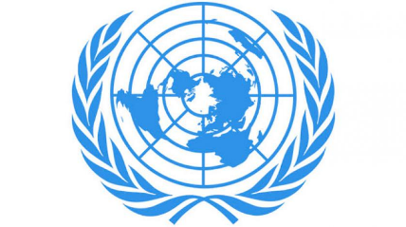
Country: Commonwealth of Australia

Committee: Disec
Topic: Israel-Palestine Conflict
Delegate: Azra Yeniçeri

Australia is a continental country located in the Southern Hemisphere, governed by a "Federal Parliamentary Democracy".

First of all, if we talk about how the conflict started, at that time, the Jewish population in the region was very small, although Jewish immigration had increased significantly. After the establishment of the Mandate of Palestine, which included a binding obligation on the British government to "establish a national home for the Jewish people in Palestine", tensions turned into conflicts between Jews and Arabs. Early attempts to resolve the conflict resulted in the 1947 United Nations Partition Plan for Palestine and the 1947-1949 Palestine war, the prelude to the broader Arab-Israeli conflict. The current Israeli-Palestinian status quo, the conflict between them started when Israel occupied Palestinian territories in the 1967 Six-Day War.
Australia has a warm and close relationship with Israel, which is strongly supported by Australia's active Jewish community. Australia was the first country to vote in favor of the 1947 United Nations resolution of partition, which eventually led to the establishment of Israel as a nation-state. Australia established diplomatic relations with Israel in 1949 and chaired the vote that same year admitting Israel to the United Nations.

It gives Israel almost unparalleled support globally at diplomatic forums such as the United Nations. In addition, Australia shares a close relationship with Israel, with important links and extensive commercial agreements. The Australian Embassy in Tel Aviv and the Israeli Embassy in Canberra opened that year.

Australia is committed to a two-state solution where Israel and a future Palestinian state coexist in peace and security within internationally recognized borders. Consistent with this long-standing policy, in December 2018 Australia recognized West Jerusalem, the seat of the Knesset and many institutions of the Israeli government, as Israel's capital. It looks forward to moving its Embassy to West Jerusalem after its determination.

Australia strongly opposes the wrongful targeting of Israel at the United Nations and other multilateral institutions. However, we openly express our concerns about Israel's actions that undermine hopes for a two-state solution and continue to urge Israel and other actors to respect international law.

The Australian Government says it “must not neglect major human rights concerns and Australia's obligations and responsibilities under international law”.

Since 2017, Australia and Israel have expanded cooperation on national security, defense, and cybersecurity. Drawing on the relevant expertise of Australia and Israel, cooperation on national security, including aviation security, continues to evolve with the Ministry of the Interior as the leading Australian agency is doing.

