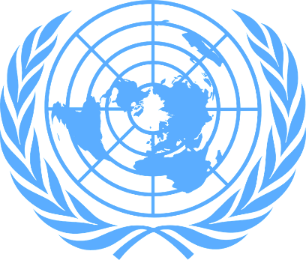

Country : Socialist Republic of Vietnam
Committee : DISEC
Topic : Israel-Palestine Conflict
Delegate : Betül Sıla Safkan

Primarily, we want to talk about Israel-Palestine Conflict. What is Israel-Palestine conflict? The Israeli-Palestinian conflict is an ongoing armed conflict between the Palestinians and the Israeli Armed Forces on Palestinian territory.

So how did the conflict start? Public announcements of claims to a Jewish homeland in Palestine, notably the First Zionist Congress of 1897 and the Balfour Declaration of 1917, created early tension in the region. Tensions escalated into conflict between Jews and Arabs after the establishment of the Mandate of Palestine, which included a binding obligation on the British government to "establish a national home for the Jewish people in Palestine". Attempts to resolve these conflicts culminated in the 1947-1949 Palestinian war, the beginning of the broader Arab-Israeli conflict with the United Nations' Plan to Partition Palestine in 1947.

Despite a long-term peace process, the Israelis and Palestinians were unable to reach a final peace agreement. Progress was made towards a two-state solution with the 1993-1995 Oslo Accords, but today Palestinians continue to be subject to Israeli military occupation in the Gaza Strip and 165 districts in the West Bank. Children, innocent people, civilian people are being killed by Israel. We as Socialist Republic of Vietnam, condemn violence against civilians and defenseless people , because it is a crime against humanity. If it is called ‘war’ , this must be between two armies.

But at this point, what should the solutions be?
Mutual trust issues are one of the reasons a rational agreement is rejected. If solution is desired, for both Zionist and Palestinian national views to work, both sides must recognize each other's right to exist and the legitimacy of their historical stories. We would like to underline an important point that ; If there is war somewhere, this should be without harming innocent people. Other solution is it is a point where Israel should stop occupying ; There is a Palestinian homeland and an Israeli homeland, and these homelands should be shared equally at best.

We think this will be a good solution for every homeland. And lastly, we hope the world stays in peace.

