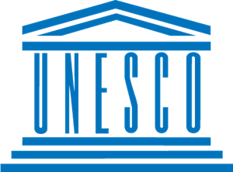
BARRİERS TO EDUCATİON IN CONFLİCT- AFFECTED COUNTRİES

COUNTRY; Kingdom of Belgium
COMMİTTEE; United Nations Educational, Scientific and Cultural Organization (UNESCO)
Education is one of the essential needs and rights of mankind. Everyone has the right to equal access to information and this right cannot be restricted, however sometimes there are situations that prevent this. In a country where there is war, education is either carried out under very difficult conditions or is completely postponed. Children and young people living in that country are not only restricted in their education rights, but also in their development and socialization needs.

During the Second World War in Belgium, education was frozen for a while, but students continued their education after a while however, students education rights were blocked during this period. The educational needs of children and young people who went to other countries as refugees due to the war could not be adequately met and these students had to stay away from their education until the end of the war. and UNESCO was established in London on 16 November 1945 to restore peace after the war and to build the education system. Children fleeing war and unable to receive education take time to adapt to society, and UNESCO is working to put an end to this. One of the most important obstacles to education during the war was the closure of most schools due to the departure of teachers and other education officials to the front. And countries have tried to improve education by realizing this problem and making new arrangements in education.

During wars families were displaced, wars broke out that victimized children in areas of armed conflict, and during this time, education became impossible. After the second world war, Unesco worked to reconstruct education by providing peace and these studies are still contining today. If a situation like this happen again, education can be done online as during the pandemic period. However, since children cannot stay without going to school for that long, shelter-like buildings can be created in safe places for education. In addition, importance should be given to refugees from other countries as much as importance is given to the education of citizens. In addition to all these, in case of teacher shortage, exams may be temporarily postponed and the school may be closed for a short time.

