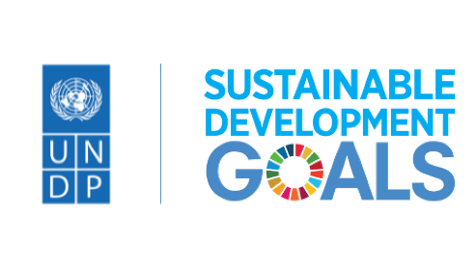
Committee: United Nations Development Programme
State: The State of Kuwait

Agenda: Decent Work and Economic Growth; Industry, Innovation and Infrastructure.

In today’s world, many people suffer from hunger, poverty and many problems caused by bad government policies. According to the United Nations (UN) the development goals set out in the Millennium Declaration express the resolve of the world’s political leaders to free their fellow men, women and children from the abject and dehumanizing conditions of extreme poverty, to make the right to development a reality for everyone, and to free the entire human race from want. In the UN analysis the world is divided in such a way that one ‘’sixth of humanity’’ has achieved levels of well-being that are very affluent by any standard. At the other extreme, another one ‘’sixth of humanity “struggles for daily survival, in a life-and-death battle against disease, hunger and environmental catastrophe. An estimated four billion people live in between these two extremes of affluence and poverty, but their standards of living are judged to be relatively far below those enjoyed by the affluent group of countries.
The above distribution of the peoples of the world implicitly uses per capita consumption expenditure (or per capita GDP) as a measure of well-being, despite the various reservations about the appropriateness of such a measure. On the basis of such measure of well-being Kuwait is fortunate to belong to the group of countries that enjoys a very affluent standard of living. In 1996 purchasing power parity dollars, the 1996 per capita GDP for Kuwait is reported as US$23386 comparable to the average GDP per capita income of five European countries which amounted to US$236653.
As is well known Kuwait is a small country with a total population in 2001 of 2.243 million. Of these 0.855 million are Kuwaitis while 1.387 million are non-Kuwaitis. The non-Kuwaitis dominate the labor force. In 2001 the total labor force is reported as being 1.214 million 80% of which were non-Kuwaitis. Most of the Kuwaiti labor force, 93%, works in the government sector while most of the non-Kuwaiti labor force, 90%, works in the non-government sector (inclusive of 28% working in the household sector). A major feature of the economy is its very low unemployment rates for the Kuwaitis, 1%, and non-Kuwaitis 0.7% with an overall unemployment rate of 0.8%4.
The first Millennium Development Goal (MDG) was to eradicate extreme poverty and hunger. Two major targets under this goal have been specified. The first target is to halve the proportion of people living in extreme poverty. The second target is to halve the proportion of people who suffer from hunger by the year 2015.
Regarding the first target, and as noted in the introduction, Kuwait is a rich country with a real per capita GDP almost equal to the average of advanced countries. Further confirmation of the level of affluence enjoyed by Kuwait is provided by the detailed information made available in the latest Household Income and Expenditure Survey for the Year 1999-2000 (HIES). According to the HIES results the average per capita expenditure for the poorest Kuwaitis amounted to KD.108.4 per month, equivalent to US$353.4 per month or about US$11.8 per person per day. This means that the average expenditure of the Kuwaiti poor is about ten times higher than the international poverty line of US$1.08 per person per day. On the basis of the above it is perhaps reasonable to conclude that as far as income poverty is concerned Kuwait has already eliminated extreme poverty for its citizens.

References:
https://pubmed.ncbi.nlm.nih.gov/12177972/
https://planipolis.iiep.unesco.org/sites/default/files/ressources/kuwait_mdg.pdf

