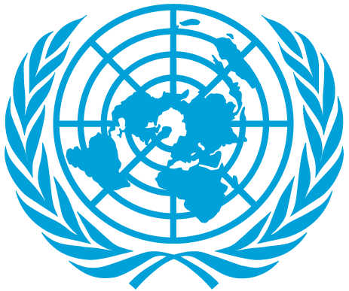
Elimination of child labor
and
Regulation and reintegration of child labor survivors

Committee: UNICEF
Topic: Elimination of Child Labor and Regulation and Reintegration of Child Labor Survivors
Country: France
Delegate: Mustafa Mert Köseoğlu , Individual

About our country:
France, or the French Republic, is the largest country in both the European Union (EU) and Western Europe. France is one of the oldest states in Europe, founded in 843. With 66 million citizens, France is also the third-largest country in terms of population. Paris, which is France’s capital, is home to approximately 2.2 million of its people. France is home to a great many attractions, including castles and historic villages that have been in existence from France’s early beginnings. Also, France ranks highly in quality of life, health, education, economic freedom, and political rights.

Our country’s policy on the matter :
France believes this topic is very important for the future of the world. Because our children are our heir. We need them as much as they need us. France is ready for any help that be given and other world countries have to be as France. Especially children living in Africa and the Middle East are having hard times. We as the great European countries. Should unite and work for a more prosperous life for those who have difficulties
All children of the world are equal. We will always defend this opinion , we are always ready for any kind of help that can be done in the field of health , in the field of education, in the field of housing and in economic terms. If a child’s smile means the whole world, all children should smile. There should not be a single crying child, because children who live away from wars , tyranny and ignorance will save our world.

Our solution idea:
In our opinion, there is no single solution. Because the factors that reveal these problems are more than one. If we take measures against of them, then we will overcome these problems.
First, we need to find the causes that reveal problems. And these are poverty, informality, cultural and social beliefs, educational problems, conflicts, lack of social protection, birth certification problem. As you see most problems reveal from economic problems. We should also attach great importance to that. Economic funds of poor countries can be helped with the helped of developed and developing countries. We can prevent childrenfrom being deprived of socialism by establishing some foundations or a commission with the help of the same countries for social support.

