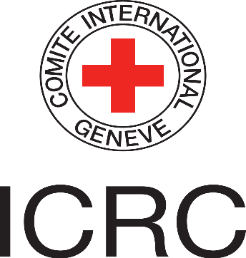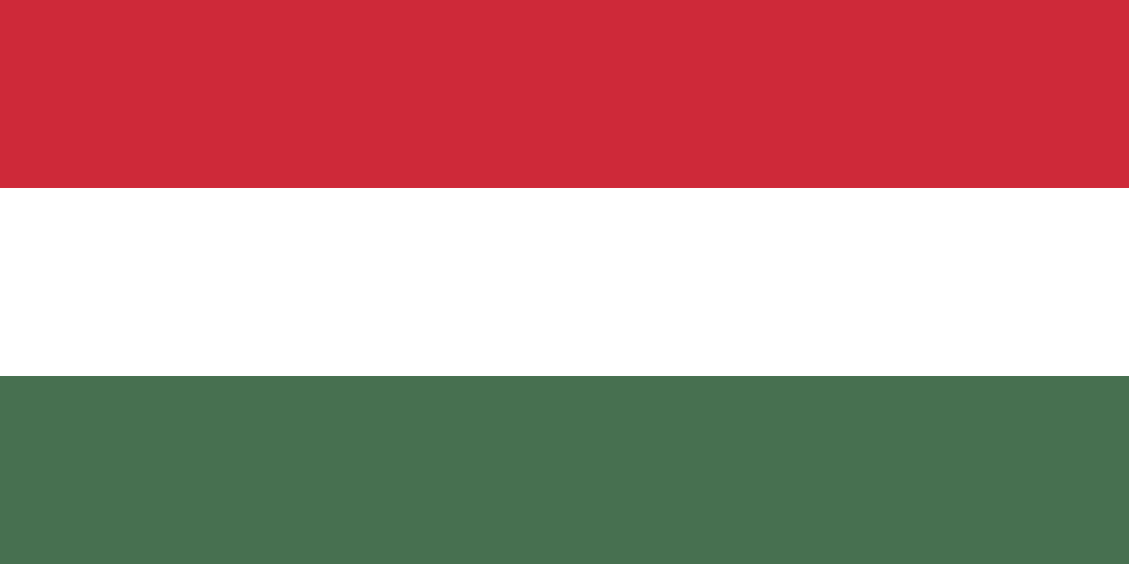
Bu Fotoğraf, Bilinmeyen Yazar, CC BY-SA altında lisanslanmıştır
Bu Fotoğraf, Bilinmeyen Yazar, CC BY-SA-NC altında lisanslanmıştır
Country: Republic of Hungry
Comittee: International Committee of Red Cross (ICRC)
Topic: Stabilizing the Distrubution of Medical Assistance in Afghanistan’s Conflict Post-Pandemic.
Delegate: Kerem AYDIN ENKA Technical Schools
The Republic of Hungary has always been a sensitive country on human rights issues. Although Hungary, a NATO and EU member, is located in Central Europe and the war in Afghanistan did not directly affect the country, it has provided serious assistance to the Afghan people who suffered from the war. Hungary sees this aid as a humanitarian duty. During the war, as a NATO member, together with its Allies (Belgium, Canada, Denmark, France, Iceland, Italy, Luxembourg, the Netherlands, Norway, Portugal, the United Kingdom, the United States, Greece, Turkey, Germany, Spain, the Czech Republic, Hungary, Poland, Bulgaria, Estonia, Latvia, Lithuania, Romania, Slovakia, Slovenia, Albania Croatia, Montenegro and North Macedonia) have always stood by the Afghan people. These aids reached the relevant people and a serious humanitarian tragedy was prevented before it occurred.
As it is known, after the withdrawal of NATO in Afghanistan, the Taliban, which was accused of using the oppressive and rigid method in Afghanistan between 1996-2001, took over the country again in 2020. After the Taliban took over the country, it declared that it would not repeat its previous mistakes and issued a general amnesty. Hungary thinks that despite the promises made by the Taliban, what the Taliban has to do is not finished. The European Union, of which Hungary is a member, requires the removal of obstacles to women's education and the prevention of discrimination against women for the continuation of aid. The Taliban took action and issued a statement on Women's rights. Although Hungary considers this statement to be a positive message, it agrees with its allies that it is insufficient. In this statement, "Women are not the property of men." key issues such as The demands expected by Hungary and the European Union, of which Hungary is a member, were not met by this declaration. No issues related to the education of women were mentioned in this paper. Due to these and similar reasons, Hungary and the European Union, of which it is a member, had to decide to temporarily suspend their aid to Afghanistan. Hungary wants to help people in need as soon as possible. Hungary hopes that in the near future, the Taliban will give due importance to women's rights and abide by the conditions set by the EU Union.
As a result, Hungary, a member of NATO and the European Union, provided the necessary assistance to the Afghan people, who had a difficult time in terms of supplying the necessary health supplies in the early days of the coronavirus pandemic. After the Taliban took control of the country, Hungary had to decide to stop these aids because the Taliban did not take the necessary steps regarding human rights and women's rights. Hungary hopes to resume providing these aids as soon as possible.
Bibliography:
https://voroskereszt.hu/en/about-us/vision-of-the-hungarian-red-cross/
http://www.kormany.hu/en
http://www.keh.hu/president_janos_ader/1582-Curriculum_vitae_of_Janos_Ader&pnr=1
https://europa.eu/european-union/about-eu/countries/member-countries/hungary_en
http://www.oecd.org/hungary/

