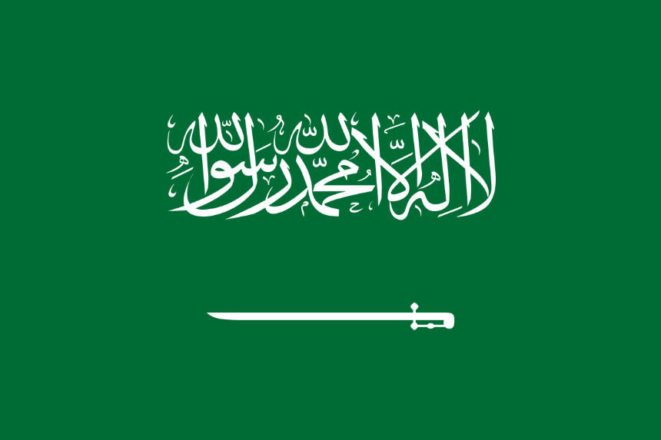
Country: Saudi Arabia
Committee: UNEP
Topic: Enhancing the transition to sustainable energy as a response to the energy crisis and climate change
Saudi Arabia, arid, sparsely populated kingdom of the Middle East.
To the east, along the Persian Gulf, are the country’s abundant oil fields that, since the 1960s, have made Saudi Arabia synonymous with petroleum wealth. Those three elements—religion, tribalism, and untold wealth—have fueled the country’s subsequent history.
Saudi Arabia will generate 50% of its energy from renewables by 2030 and plant 10 billion trees in coming decades. This is part of efforts to diversify the economy away from its oil dependence. Also Saudi Arabia is working on “clean hydrocarbon” projects to make fossil fuels less polluting and starts the largest renewables project ever announced: $200bn (£158bn) worth of solar panels stretching across hundreds of square kilometres of the Saudi Arabian desert.
Saudi Arabia aims to reach net zero greenhouse gas emissions by 2060 to curb manmade climate change. The kingdom joins the ranks of Russia and China on their stated net zero target date of 2060. The US and the EU have aimed for 2050.
Saudi Arabia criticises those who say fossil fuels must be urgently phased out, warning a premature switch could lead to price volatility and shortages.
We should work on renewable energy for the sake of humanity and earth.

https://www.theguardian.com
https://www.climatescorecard.org
https://oxfordbusinessgroup.com
https://www.climatechangenews.com
https://marketrealist.com
https://www.britannica.com
https://www.climatescorecard.org
https://en.wikipedia.org

