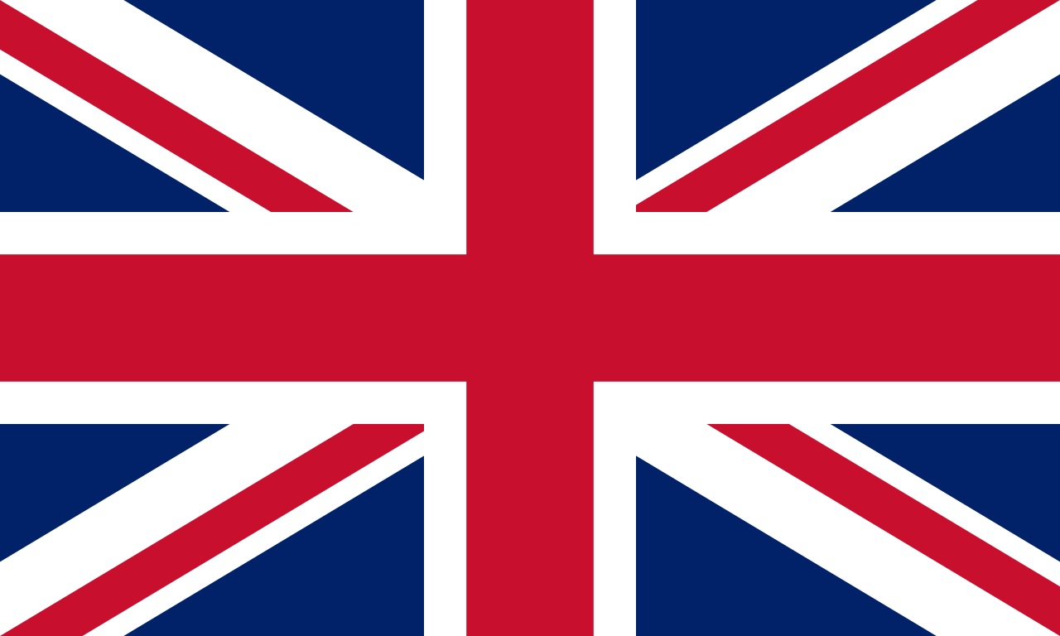
Country:UK
Committee:DISEC
Topic:The Conflict Between Israel and Palestine

The United Kingdom is a country located at the crossroads of Northwestern and Central Europe which has a total area of 242.495 km^2. The UK has a approximately 67.22 million
inhabitants (as of December 2020).It also includes 2 founder nations which are Great Britain that contains England,Scotland and Wales and Northern Ireland.The United Kingdom has always been closely related to politics and international relations in its history since its establishment in 1922. Due to this fact, the conflict between Israel and Palestine concerns The UK governmental as well as the other governments of other states.

In the early 17th centuries BC following the call of their god,three patriarchs of the Jewish people (Abraham,Isaac and Jacob) Settled in Canaan a region approximating present-day Israel, the West Bank and the Gaza Strip parts of Lebanon,Syria and Jordan. The region later had the name The Land of Israel,The Promised Land,The Palestine Region and The Holy Land.In 1000 BC King Saul established the Israelite Monarchy which then was ruled by King David who made Jerusalem the capital of his kingdom.After the death of King Salamon who is the son of King David,The United Monarchy was split into The Kingdom of Israel in the north and The Kingdom of Judah in the south.The both lands became home to a majority of Jews but then it was subject to numerous conquests of various groups leading to the significant decrease of the Jewish population on the land.One of these conquests was conducted by The Roman Empire who gave the name Palestine to Judah and intending the Jewish connection with The Land of Israel.During this time Chirstianity which started as a Jewish sect ultimately became a dominant religion toward the end of The Roman Emprie.In the 7th century came an Arab conquest beginning the spread of Islam making the Jrusalem the Holy Ctiy to both three monothestich religions.After the conquest of the Seljuk Turks, The Christians could not take their holy lands back, despite the raids which was made by them in the region.During this time many Jews were killed. From the 16th century to The World War One The Holy Lands were ruled by The Ottoman Empire.At the same time in Europe a lot of Jewish were joining a movement called Zionisim which was aiming to create a national Jewish State in The Holy Lands of ancient Jewishes and to achieve their goal a lot of Jewish has moved back to the region.

After the collapsation of The Ottoman Empire, ıts land in the middle east was carved by the British and French Empires.Then The Britishes gave more independence for Iraq and Jordan and The British Mandate of the Palestine was the name of the land that Britians still held.After all,the conflict between Jews and Arabs who both claimed the land grew and even led the acts of violence movements of Arabs.After the immigration of many Jews in Europe to Palestine due to the Nazi massacres in the 1930s, the British state left the region to the Jews and completely withdrew from the region.After The World War Two,The United Nations (Mostly The UK) proposed a plan partition Palastine in to two independent governments,a Jewish Government and an Arab Government with the city of Jerusalem becoming an international zone with a special status.This caused the Arabs to not accept this much land and to attack the Jews with volunteer armies.This satuations led a Arab Israeli war in 1948.In this war Arabs (Syriyans,Jordanians,Lebnanese,Iraqis and Eygptians) united and attacked Israel, an independent Jewish state.This war was won by the Jews with the support of the United Kingdom, despite all the massacres and acts of violence by the Arabs.Since then Arabs and Jews at the region are in a conflict wich recurrented in 2021.

We as the United Kingdom advocate that all nations should unite and condemn the violent acts and harmful activities of Arabs in the mentioned region.

