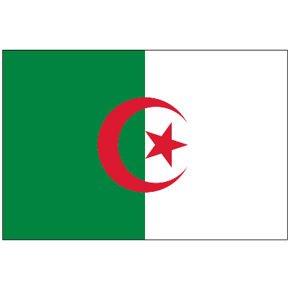
Country: Algeria
Committee: International Committee of Red Cross
Topic: Stabilizing the distribution of medical assistance in Afghanistan's conflict post-pandemic

The Algerian Red Crescent society was born out of the preliminary humanitarian missions by the Internal Committee of the Red Cross (ICRC) during the Algerian War of 1954–1962. During the 1990s, Algeria experienced years of violence and internal disturbances, which impacted on the economy and adversely affected the social conditions of the population. The Algerian Red Crescent has a development plan and strategy with the following main goals: increased international relations with both the Red Cross Red Crescent network and the ICRC, and with bodies involved in humanitarian activities; developing a major programme to teach and disseminate humanitarian principles; encouraging and developing a large network of women with the society; and establishing a partnership based on complementarity, transparency and mutual respect in solidarity programmes with national and foreign organizations.
Afghanistan is currently facing economic collapse and a humanitarian crisis. This is taking place in a context where the population has already borne the brunt of 40 years of war, recurrent natural disasters, chronic poverty, drought, and the Covid-19 pandemic.
The Turkish Red Crescent on Thursday distributed food aid to 500 families in Afghanistan’s northern Balkh province, it said in a statement. Turkey's "Kindness Train" carrying nearly 750 tons of humanitarian aid to Afghanistan is expected to reach its final destination on Feb. 9, Turkish Red Crescent head Kerem Kınık said Saturday and called for a global mobilization campaign for Afghanistan amid the ongoing humanitarian crisis in the country.
Algeria agrees and supports Turkey on this issue.
Thank you.

Resources:
https://en.wikipedia.org/wiki/Algerian_Red_Crescent
https://reliefweb.int/report/afghanistan/afghanistan-frontline-afghanistans-humanitarian-crisis
https://www.aa.com.tr/en/asia-pacific/turkish-red-crescent-distributes-aid-in-afghanistan/2118343

