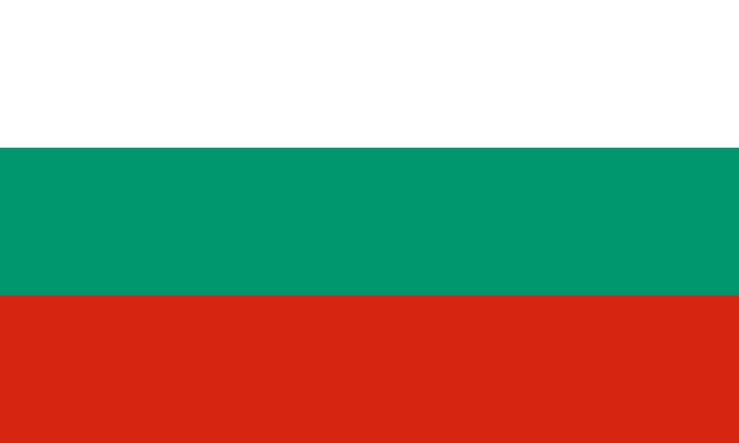
Committee: International Committee of Red Cross
Topic: Stabilizing the distribution of medical assistance in Afghanistan's conflict post-pandemic
Country: Bulgaria
Delegate: Elifsu Güdük

The mission of the International Committee of the Red Cross is to protect human life and dignity and to help victims of war and internal conflict all over the world. The International Federation of Red Cross and Red Crescent Societies aims to improve the lives of powerless and needy people all over the world by mobilizing the power of humanism.
The ICRC is responding to the humanitarian crisis in Afghanistan by providing health care, supporting health care infrastructure, rehabilitation support, assisting people to establish livelihoods and incomes, helping families who have been separated reconnect, improving access to clean water, sanitation and energy, together with the Afghan Red Crescent, and other Movement partners.
Since the beginning of the COVID-19 pandemic, climate-related disasters have affected the lives of at least 139.2 million people and killed more than 17,242.

All reasons aside, The Bulgarian Red Cross position is definite and determined. We express its deep concern over the health problems in Afghanistan. The Bulgarian Red Cross is part of the International Red Cross and Red Crescent Movement - the largest global humanitarian network and is guided in its work by its fundamental principles: humanity, impartiality, neutrality, independence, voluntary service, unity and universality. We have been seeking quick resolutions for the conflicts. Humane treatment of all human beings. Protection of the vulnerable. And prevention of suffering.

Conflict, extreme drought, and the COVID-19 pandemic have converged, with thousands newly displaced by the conflict and millions more suffering food shortages and hunger.
Currently, one of the worst droughts in decades is crippling food production across the country and nearly one third of Afghanistan’s population is experiencing high levels of acute food shortages. With the support of the IFRC, the Afghan Red Crescent is providing families who have lost their livelihoods due to the drought with cash grants to buy food supplies and to restore crops.
The ICRC, whose medical teams run physical rehabilitation centers in Afghanistan, treated more than 40,000 people wounded by weapons at ICRC-supported facilities last summer.

As the Delegate of Bulgaria, We would like to end the breakouts and suspensions up as soon as possible. Due to this wish, we guess all countries have the same consensus. We would like to encourage the Afghanistan delegation to take the vital steps and decisions about education of girls and health to receive the support from this helpful and important organization.

Sources

https://www.ifrc.org/press-release/more-139-million-people-hit-climate-crisis-and-covid-19-new-ifrc-analysis-reveals

https://www.icrc.org/en/where-we-work/asia-pacific/afghanistan

https://reliefweb.int/report/afghanistan/red-cross-aid-work-afghanistan-continues

https://www.redcross.org.cy/tr/about-us/international-red-cross

https://en.redcross.bg/news/view?nwid=24227

https://news.un.org/en/story/2021/09/1100652

https://www.icrc.org/en/document/icrc-scales-support-health-care

https://www.icrc.org/en/document/mardini-afghan-people-above-politics

