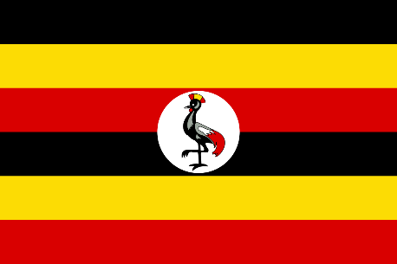
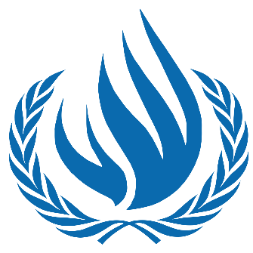
Country: Uganda
Committee: UNHRC(United Nations Human
Rights Council)
Agenda Item(s): Refugee Crisis: Forcibly
Displaced and Stateless People

POSITION PAPER
The Republic of Uganda is a country located in the eastern part of the African continent. Its official language is English and the capital city is Kampala. Its currency is USH and its population is more than 42 million and more than %50 of them are children. Uganda also hosts the largest refugee population in Africa.
The human rights have been affected by Covid-19, too. Due to of Covid-19 pandemic, the schools were closed on March 18, 2020 . Uganda hosts around 1.5 million refugees and we want them to have the best education. Tuition fees have been abolished in Uganda so that schools do not incur other costs that can create barriers for students from low-income households and students living in poverty. Also, poverty affects the human rights in a bad way, too. Wars and violence in South Sudan and the Democratic Republic of the Congo are forcing people to migrate to Uganda. Some of these people don’t have houses due to economic problems. Efforts are being made to prevent situations that violate human rights in Uganda and we have a solution for these kind of sutiations, too.
We want our people and refugees to have a better life so we want to do our best to help them have better houses and education. To help refugees, some organizations have been opened in Uganda. They help their safety and security, their education and people are donating Money for them. We also are ready to do everything we can do to help the schools and refugees all around the world economically. We hope it will be better for people's rights and happiness.

