Delegate: Belinay Şule BAL
Country : Portugal
Comittee : WHO (World Health Organization)
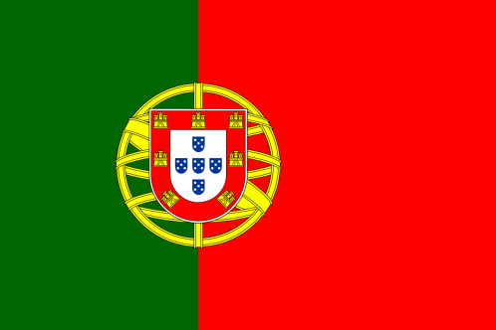
Agenda Item(s) : New Normal After the Covid 19 Pandemic and the Role of Vaccination

Portugal is a country located in southwestern Europe. It is surrounded by Spain to the north and east, and the Atlantic Ocean to the south and west. The capital of Portugal is Lisbon. It is a medium-sized country, typically with a population of more than 10 million people. The most common religion is Christianity.
Corona did not affect Portugal as much as it affected other countries. The number of cases in 2022 is 3,604,114. During some periods when the virus was more transmitted, some restaurants and shopping centers were closed. However, there is another reason why the virus did not affect Portugal that much. People acted very carefully in this regard and obeyed the rules.
We think that we can agree on this issue with other countries. Implementing the measures we have taken in other countries is also important for the future of the world. That's why we will accept any kind of project that fits within our budget.

