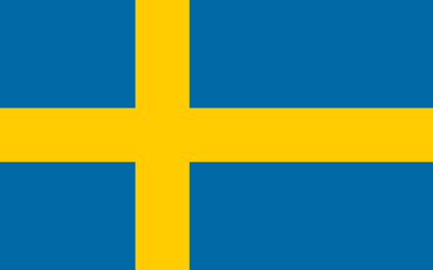
Committee: UNESCO-2
Country: Sweden
Agenda Item: Barriers to education in conflict-affected countries

As we all know, conflicts between countries affect most of us. Many of these conflicts occur because of numerous reasons such as an ongoing problem or a problem associated with a previous one. As the world break down in pieces and people suffer for their lives the most innocent ones, children, are stuck in between. Crisis lead to deprivation of many children rights around the world including health, nutrition, safety and education. Child soldiers under the age of 18 are used as objects, sometimes as a shield or a suicide bomber in these conflicts. This is a real violation of the mankind's prime right: right to live. Conflict-affected countries include over 20% of all children who are at primary school age, but also around half of all out-of-school children of primary school age. The likelihood of young children dropping out of school is also significantly higher in conflict-affected countries than elsewhere in the world: only 65% of children in these countries attend the last primary school grade. Is it right to condone all these while the lives of future generations are destroyed before our eyes? As Sweden we don't support that. We believe we must work as a whole to save those small souls who are afraid to get hurt because of the wars all around them. We must not forget that conflicts shouldn't have an effect on them. These conflicts significantly affect girls. Girls may be kept from school by their parents in fear of violence against female students.

Sweden is one of UNICEF’s strongest partners, helping to reach millions of vulnerable children with life-saving assistance. Though Sweden doesn't confront this kind of problems now, we are happy to help other countries. Conflicts happen all around the world everyday injuring people mentally and physically. And we will be grateful to have an opportunity to help them and not spare any of our sources. Sweden has been working in emergency situations in Africa since 1958.

It is clear that there are some certain ways to help these children live their lives peacefully getting the education they deserve. First of all, our first aim should be harming less civilians as possible and solving problems between countries on paper. Secondly, Sweden has confronted many wars in the past and our children have suffered a lot. In time, we have understood that the only way to make them effected less is democracy. Without democracy it is barely possible to think other requisites like freedom and equality and justice. For this reason since infancy we have raised our children with these virtues. We have put concepts like human rights into our curriculum teaching children morals, accepting differences. Thanks to our education systems we have become a country living in solidarity. We suggest to countries who are in or have been in conflicts till now that education children with these morals would help the countries future when they grow up. By this way citizens with peaceful way of thinking will be the next generation. Thirdly, most drop outs happen during or after a war. Schools and universities have been destroyed or damaged. Many families become unable to afford school fees as well as other needs. So they apply to the easiest way, getting the kids out of school than starving. This is the moment when everything changes. Children with bright futures become obliged to work at fields, allocating money in hopes of helping their families. So, from our point of view, when especially everything is over, countries with strong economies should give a hand to these people. We may build new schools for children to learn, give them enough aid to feel safe.

