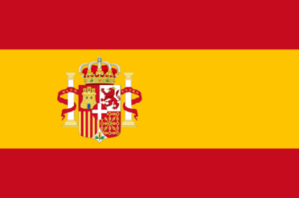
Committee: UNESCO 2
Country: Spain
Delegate: Efsa KILINÇARSLAN
Topic: Barriers to education in conflict-affected countries.

Spain is a country, located in southwestern Europe. Spain’s capital and the largest city is Madrid. Spanish, is the official language and is spoken by more than 400 million people in Latin America and Spain is known for its long history, unique culture, strong economy and very high living standards.
Being a child during a time of armed conflict, however, is not an easy experience. Armed conflicts affect millions of children, their daily life being disturbed by acts of atrocity which will mark their future. This reality affects a essential right of children: their education. The Basque Conflict, also known as the Spain-ETA conflict was an armed conflict.. It has previously been shown that conflict affects many economic factors, including education, which has an important role in development and economic growth. It is shown that, under relatively general circumstances, individuals living in a conflict area have an encouragement to increase their grade of education. This means that, the inhibition of education incentive people to increase their level of education individually. There are many things that prevent training. One of them is Covid-19, our planets biggest issue nowadays. In our country, there have been a number of classrooms quarantined, as well as some schools temporarily closed due to Covid outbreaks. Many universities have combined online tuition with face-to-face. Covid outbreaks affected millions of pupils and teachers all over the world. Some students couldn't join to the online lessons, some of them didn't have any technological tools to attend to the lessons and so many other situations happened that blocked children to join online lessons. Another issue that affects training is, protests. Recently, in Spain thousands of Catalans took to the streets in and around Barcelona’s Passeig de Sant Joan to defend the Catalan language immersion system in schools. But some families who want their children to receive more learning in Spanish say the current system is violating their rights to study in the nation’s common tongue. This time we are talking about PISA tests. A journalist named Elisa Silió, said that Spanish high school students performed worse on PISA tests than Finnish pupils, even tough they spend 246 more hours in the classroom. A student at a Spanish high school receives 1,045 hours of class time a year – 246 more than a Finnish student– but performs worse on average on the Program for International Student Assessment (PISA) test. Andreas Schleicher, the head of PISA Tests: more class time does not guarantee a better education. In Spain, according to some Spanish people's ideas, situations like unqualified teachers, basic competencies, memorizing concepts prevents education.
Spain expects peace and goodness in the world. Education in our country is one of our most important priorities. We believe that education is important for our country's future. If we share the same world, if we care about our future we should do something. Children shouldn't get affected because of our issues. They shouldn't be away from education. Because education will save us. We should work together to solve problems. In that case, we will not affect children and education. Peace at home, peace in the world.

