New Normal After The Covid-19 Pandemic
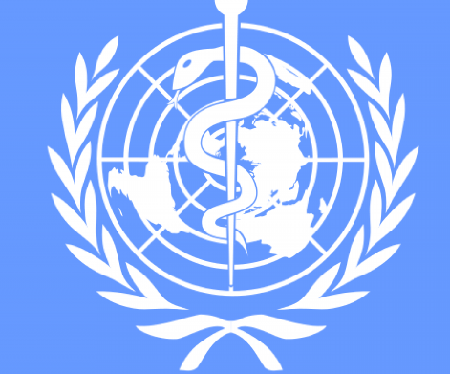
And The Role Of Vaccination.

Country: Switzerland
Committee: WHO
Delegate: Selin Yüce

In recent years, Covid-19 has started to play a big role in our world. In the last two years, everyone has started to be interested in this. Our world is started to get worse but a few months ago, scientists was put forward a vaccine. Finally, vaccination started to reduce the number of deaths.
Also, in Switzerland we are not behind all countries. We started a campaign. Our first vaccine was done in Zurich. Our first patient was a 90 years old woman. Our citizens are able to receive the Covid-19 vaccine free of charge through the Ministry of Health. However, some people weren’t happy either. They think vaccination is not easy for everyone. They think it has to be easier.
We want to be more professional about vaccination. That’s why we want help. We need to be faster. We don't want our people to die as their lives matter just like all the other people on the Earth. We as Switzerland promise that we will do everything for them.

