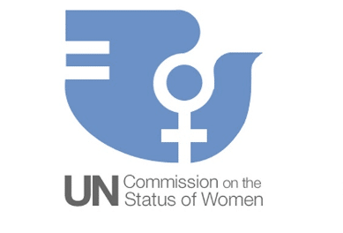

Country:China

Committee:Commission on the Status of Woman (CSW)

Agenda Item:Promoting gender equality and the empowerment of women

Gender equality is not only a fundamental human right, but a necessary foundation for a peaceful, prosperous and sustainable world. Women and girls are key agents of development and change. Achieving gender equality and empowering women and girls is vital to building fair, inclusive, prosperous and peaceful societies everywhere. There has been progress over the last decades, but the world is not on track to achieve gender equality by 2030.Gender equality and the empowerment of women and girls are prerequisites to the realisation of the 2030 Agenda for Sustainable Development.

In China, equality of men and women has been stipulated in the Constitution since 1954. More than 100 laws and regulations have been formulated or amended to provide fundamental guarantees for promoting women’s development and safeguarding women’s rights and interests. Women account for half of China's poverty reduction population and more than 40 per cent of the employed population. In 2018, the net primary school enrolment rates of boys and girls were both very close to 100% and the number of female graduate students in higher education accounted for 49.6% of all graduate students. The maternal mortality ratio has significantly fallen from 89 per 100,000 live births in 1990 to 16.9 per 100,000 live births in 2020. Despite progress in tackling gender inequality, gender-based violence, forms of harmful practices and discrimination persist. Working in China since 1998, UN Women provides technical and financial assistance to innovative programmes and strategies for gender equality and women's empowerment.UN Women works in partnership with governments, non-governmental organisations (NGOs), UN agencies, donors, communities and networks to advance gender equality.

Violence against Women,this fundamental violation of women’s rights remains widespread. Women need strong laws, backed by implementation and services for protection and prevention.Leadership and Political Participation, whether in political bodies or corporate boardrooms, women have a limited say in the decisions that affect them. Measures are needed to open more space for women’s participation and help women realize their full leadership potential.Economic Empowerment Women,lag far behind men in access to land, credit and decent jobs, even though a growing body of research shows that enhancing women’s economic options boosts national economies.National Planning and Budgeting ,Public planning often overlooks women’s specific needs and priorities. Gender equality should be a stated objective of all plans, backed by specific actions for implementation and sufficient funding.