Position Paper
Country: The Arab Republic of Egypt
Committee: UNODC
Topic: The Usage of Appearance and Performance Enhancing Drugs (APEDs) and Sports: Their Interconnection

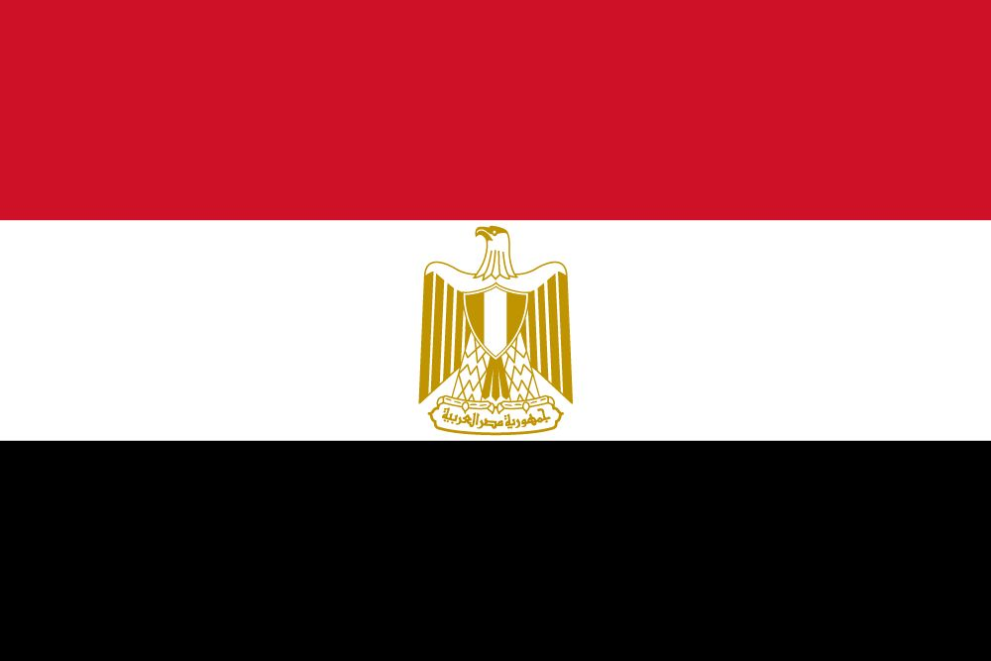

The Arab Republic of Egypt
Egypt is a transcontinental country spanning the northeast corner of Africa and southwest corner of Asia. It’s the second biggest of the Arab countries; however, only 4% of Egypt’s area is inhabited and cultivated territory and the remainder of the country is mainly desert. Egypt has a population of 101.5 million people. It is largely composed of Egyptians, who make up the %99.7 of the population. Most of the country are identified as Muslims but there’s a Christian minority too. Its official language is Arabic.

APEDs

Appearance and performance enhancing drugs (APEDs) are most often used by males to improve appearance by building muscle mass or to enhance athletic performance. Even though APEDs can affect people’s moods, they do not produce a euphoric high, which makes APEDs distinct from other drugs. Despite this, it is possible for people to develop a substance use disorder, defined as continued use despite adverse consequences. They can lead to early heart attacks, strokes, liver tumors, kidney failure, and psychiatric problems. Furthermore, stopping can cause depression, which makes it easier to get addicted.

Egypt and UNODC’s Cooperations
UNODC and Egypt have a long history of cooperation in addressing the negative social and health effects of drug abuse in the country; a partnership that endures to this day. UNODC has actively contributed to the National Plan on Combating Drug Abuse, which since 2013 has delivered a common strategy addressing the drug problem in Egypt. The United Nations Office on Drugs and Crime signed a Memorandum of Understanding with the Prosecutor General of Egypt on the margins of the ninth Conference of the Parties to the United Nations Convention on Transnational Organized Crime, reflecting the long-standing partnership aimed at strengthening Egypt's criminal justice system.

Egypt’s Policy Against Drugs
Egypt is party to the 1961, 1971 and 1988 international drug control conventions. Its national drug control laws are generally assessed as adequate. The lists of scheduled drugs are regularly updated according to developments in drug trafficking and illicit consumption. The Government of Egypt continues to aggressively pursue a comprehensive drug control strategy that was developed in 1998. ANGA, the Egyptian Ministry of Interior, the Coast Guard, the Customs Service, and select military units all cooperate in task forces designed to interdict narcotics shipments. UNODC is, therefore, undertaken several Rapid Assessment Studies in Egypt in cooperation with the Ministry of Health the latest in August 2004.
APEDs and Sports
Building up muscle isn't the only effect of taking androgenic steroids; they also have a more immediate effect. The steroids can increase the amount of heat-shock proteins in muscle. These proteins help protect the muscle cells during very intense exercise, such as weightlifting or sprinting. In professional sports competitions, this can create an unfair advantage to other competitors which is why ‘The World Anti-Doping Agency’ (WADA) maintains an extensive list of substances and methods that might increase performance and that are banned during competitions, and in some cases, banned for use even when athletes aren't competing. IOC Anti-Doping Rules states ‘It is the Athletes’ personal duty to ensure that no Prohibited Substance enters their bodies and that no Prohibited Method is Used.’
Egypt annually participates in International Anti-Corruption Day, which is commemorated annually on 9 December in recognition of the United Nations Convention against Corruption, which was adopted in 2003 and entered into force in 2005 and is aimed at safeguarding sport from corruption and preventing the manipulation of sports competitions. We believe events that promote sports and fair play like this can be beneficial in reducing the usage of APEDs as well as the reinforcement of the drugs themselves.

Bibliography
- https://www.unodc.org/pdf/egypt/egypt_country_profile.pdf
- https://www.drugabuse.gov/publications/research-reports/steroids-other-appearance-performance-enhancing-drugs-apeds/introduction#:~:text=Research%20Report-,Steroids%20and%20Other%20Appearance%20and%20Performance%20Enhancing%20Drugs%20(APEDs)%20Research,or%20to%20enhance%20athletic%20performance
- https://www.drugabuse.gov/publications/research-reports/steroids-other-appearance-performance-enhancing-drugs-apeds/who-uses-anabolic-steroids
- https://www.livescience.com/55723-banned-doping-drugs.html
- https://stillmedab.olympic.org/media/Document%20Library/OlympicOrg/Games/Summer-Games/Games-Tokyo-2020-Olympic-Games/Anti-Doping-and-Medical-Rules/IOC-Anti-Doping-Rules-Tokyo-2020.pdf
- https://www.drugabuse.gov/publications/research-reports/steroids-other-appearance-performance-enhancing-drugs-apeds/why-are-anabolic-steroids-misused
- https://www.unodc.org/unodc/en/speeches/2017/cnd-egypt-160317.html
- https://www.unodc.org/unodc/en/frontpage/2018/October/unodc-and-egypt-sign-agreement-to-strengthen-cooperation-against-crime.html
- https://www.mayoclinic.org/healthy-lifestyle/fitness/in-depth/performance-enhancing-drugs/art-20046134
- https://www.unodc.org/unodc/en/frontpage/2020/December/safeguarding-sport-from-corruption-in-egypt_-unodc-and-aca--supported-by-ioc-and-fifa--organize-hybrid-workshop.html

