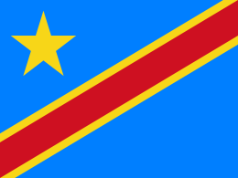
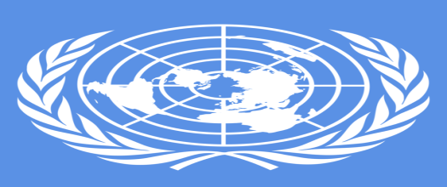

Country: Democratic Republic of the Congo
Committee: United Nations Human Rights Council(UNHRC)
Agenda Item: Refugee Crisis: Forcibly displaced and stateless people

The Democratic Republic of the Congo or Formerly Zaire is a country in Central Africa. In terms of area, it is the largest country in Sub-Saharan Africa, the second largest in Africa and the 11th largest in the world. It is the most populous Francophone country with a population of 105 million. It is also the 4th most populous country in Africa and the 15th in the world. The capital of the country is Kinshasa.
Congo, like other countries, is affected by migrant crises. Currently, there is a migrant crisis on the agenda of most countries (like Congo). This situation particularly affects Africa, Asia and Europe. Since Congo is an African country, it is affected by this situation. This situation also showed itself in the Congo crises. We should also examine the migration problem here. The main causes of migration are wars, poverty and limited freedoms depending on the economic situation and climate.
The best example that can be given from the past in this regard is the Hutu-Tutsi war and the massacres that took place during this war. Population mobility after this war should never be forgotten. Again, hunger caused by almost regular droughts and poverty in general cause migration. Again, the limited freedom environment and lack of democracy should not be forgotten
Some other African countries, such as the Congo, are also affected by migrant crises. In fact, not only African countries, but also almost the whole world is affected by this situation. Eritrea, Nigeria, Somalia, Sudan, Gambia in Africa; Afghanistan, Pakistan, Bangladesh in Asia and Serbia, Kosovo and Albania in the Balkans are in this situation.
These migrant crises can be due to many reasons. For example, if a crisis occurs in the country, this situation may occur (Congo crisis) or if natural disasters occur in the country (such as earthquake, flood, forest fire), immigration may occur again. And this situation should be solved urgently by taking the necessary precautions (yes, of course, natural disasters cannot be solved completely, but this situation can be overcome slightly by taking precautions) because people are left stateless due to these experiences. In addition, this situation affects the whole world, that is, the whole world suffers the fault of the country with the immigrant problem.
In order to solve this immigration and migration problem that occurs all over the world, all countries, including the Republic of Congo, should prevent migration by offering equal, fair, opportunities and the right to food, shelter and life rights.

