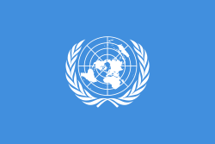
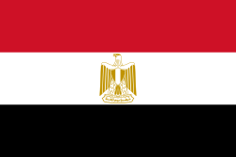
Committee: UNESCO (United Nations Educational, Scientific and Cultural Organization)
Topic : Barriers to Education in Conflict-Affected Countries
Country: Egypt

Egypt, or officially the Arab Republic of Egypt, is a country located at the intersection of the African and Asian continents. It is the most populous country in North Africa. Until the 19th century, education in Egypt was largely under the control of religious authority. Both the Islamic authority and the Coptic Church had schools at the primary, secondary and high school level. In these institutions, besides religious lessons, mainly Arabic and mathematics curricula were applied.
The Egyptian Government has given more priority to the improvement of the education system. Many school-age children around the world are deprived of educational opportunities due to illness, financial difficulties, natural disasters and opposition to gender equality. Not only these, but also people fall into difficult situations because of wars. Children's schools are bombed, people cannot leave their homes. In such cases, education is thrown into the background and basic needs come to the fore, so there is no healthy education in a war environment. Schools turn into police stations and unfortunately students go to school in the shadow of death.

The most important feature of Egypt is this: We cannot remain silent about this situation, we argue that starting today, we can lay the foundations of tomorrow, we attach importance to education. because we can only save the world if we break out of the mold and look through the window of education.

