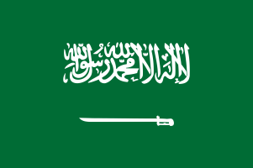
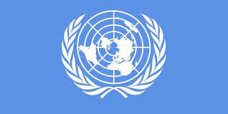

Committee: WHO (World Health Organization)
Topic : New normal after the COVID-19 pandemic and the role of vaccination
Delegate. Saudi Arabia
School: Denizli Merkezefendi Ülker Yörükoğlu Science and Art Centre
Saudi Arabia, or officially the Kingdom of Saudi Arabia (Arabic: المملكة العربية السعودية, al-Memleketü'l-Arabiyyetü's-Suûdiyye), is the largest country in the Arabian Peninsula.
According to Islam, the two holy cities of Mecca and Medina are in this country. Saudi Arabia, like all Gulf countries in the Middle East, is developing rapidly.
Saudi Arabia is a kingdom where sharia laws are adopted as a constitution. The king, who holds both executive and legislative power, appoints the Council of Ministers himself and has the right to veto its decisions.[9] More or less all important management decisions are made by the Saudi family. Although there is neither a political party nor a legislature, every citizen can submit their complaints to the king and ask for his help by directly applying to the regular listening sessions called "parliament".The majority of Saudi Arabians are Arabs descended from indigenous tribes. The official language, Arabic and its various dialects, are spoken by the entire population. 97% of the population is Muslim.
It was confirmed on March 2, 2020 that the ongoing COVID-19 pandemic has spread to Saudi Arabia.[ February 27: All Umrah visits are suspended.[9]
March 2020 It was reported that the way for direct entries to Saudi Arabia, including African countries, was also opened.He said that there has been a 95 percent decrease in the number of cases in the country compared to the last weeks, and the critical case rate has decreased by 62 percent. In the statement, it was stated that the total number of doses exceeded 61 million, the number of those who received two doses of vaccination reached 24 million, and over 11 million booster doses were administered. It was emphasized that the Kovid-19 vaccines were effective in protecting public health and reducing the number of critical cases.
Various institutions and organizations have been working on the fight against the epidemic in Saudi Arabia since the start of the pandemic. In the statements made, it was stated that the people living in the country adhered to the measures taken at a high rate and did not neglect to be vaccinated, and the community immunity increased to high levels.
As a result, although the pandemic is our reality of life, we have all lived and experienced that the measures we will take are important for the whole world. As the whole world, we have adapted to the new normals in order to protect humanity. We have witnessed that masks, vaccines and individual measures save lives.It is the duty of humanity to fulfill our duties as the countries of the world while passing through a difficult test as humanity. We owe a debt of gratitude to all the citizens of the world who contributed to this.

