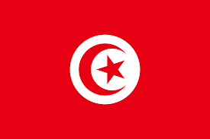Country: Tunisia
Committee: UNESCO
Agenda Topic: Barriers to education in conflict-affected countries
Tunisia has been a conflict-affected country since the revolution of 2011 which was part of the ‘Arab Springs’ uprising. However, in the decade that followed we have continued to rebuild our infrastructure. Education is a high priority in Tunisia and it has been for the many years since our independence in 1956 and is paramount to our current and future economic and social development. Indeed, Tunisia has been among the countries with the highest investment in education in the region. The United Nations, together with the United Nations Country Team (UNCT), is working with us and contributes to the planning of the next five-year Cooperation Framework that will constitute the backbone of the UN collaboration with our Government for the period (2021-2025). These measures will ensure that we can work towards stability and secure equal educational opportunities for our school-age population. Tunisia’s national laws on education and the level of access to primary education is reflected in our impressive school enrolment rates.
Tunisia signed the Safe Schools Declaration in February, 2022 and we strongly support the mandate of the declaration. We agree to ensure that every child has a right to education in a safe environment without the threat of violence. Furtheremore, we are committed to ensuring that every teacher, professor, and school administrator should be able to teach and research in conditions of safety, security, and dignity. It is our duty to the children of the global community to implement initiatives and strategies that will successfully achieve these goals.
In addition, Tunisia is also committed to the Sustainable Development Goals (SDGs) and we presented our second National Voluntary Report in 2021. As part of the SDGs we call on all member states to ensure inclusive and equitable quality education and promote lifelong learning opportunities for all.

