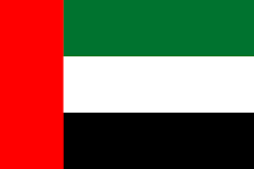Country: United Arab Emirates
Committee: UNHRC
Agenda Topic: Refugee Crisis: forcibly displaced and stateless people.
As of 2019, there are around 68 million refugees which include forcibly displaced and stateless people. Forced displacement is a rising issue and one of the main challenges facing people who find themselves in this situation is access to adequate shelter in which their needs are being met. The United Arab Emirates has been consistently working on introducing sustainable solutions to the untold suffering experienced by refugees and displaced people in various parts of the world.
There have been colossal efforts made by the UAE to restore stability and security in conflict zones and border areas where refugees and forcibly displaced people, are living. The UAE has urged the internationally community to exert more significant efforts to provide refugees with better living conditions. We have noted increasing numbers of refugees and forcibly displaced people as a result of the eruption of bitter conflicts and crises in a number of countries around the globe that resulted in the alarming illegitimate immigration of hundreds of thousands of peoples.
The UAE has an established partnership between the Emirates Red Crescent (ERC) and the UNHCR. The ERC highlighted the importance of such types of projects to empowering refugees economically and encouraging them to work, develop and benefit from their skills, as well as enabling them to continue living with dignity.
In addition, the UAE is the largest donor to humanitarian and development aid in the world and has donated $750 million since 2012. We have shown through our refugee policy and our constructive actions that UAE is invested in helping the most vulnerable members of the global community who are experience the most horrific circumstance. We will continue to advocate for their wellbeing and remain committed to the mandate set down by the UNHRC.

