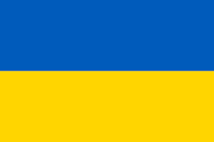Country: Ukraine
Committee: WHO
Agenda Topic: New normal after Covid 19 and the role of vaccination.
The onset of the Covid 19 virus proved to be a strong challenge to Ukraine’s government and citizens, however, with commitment and positive actions we are well on our way to vaccinating our population. Vaccination against COVID-19 in Ukraine started on 24 February 2021As part of the EU and WHO/Europe partnership to support the deployment of COVID-19 vaccines and vaccination in the Ukraine.
The Program Development Objective is to prevent, detect and respond to the threat posed by COVID-19 and strengthen the national health system for public health preparedness in Ukraine. We are commited to providing vaccinations to all of our citizens and welcome input and support from the UN and all of the related agencies.
In Ukraine, 10,682,752 people already received at least the first shot of the COVID-19 vaccine, and 7,596,587 got two doses and now are fully protected, as of November 3, 2021. We will move forward with our vaccination programme and ensure that the population is fully vaccinated and safe.
No matter what challenges the country is facing, we guarantee our utmost attention and care to our population to safeguard them from the threat of Covid 19. It is our duty to implement initiatives that will produce a successful outcome that is inline with out goals.

