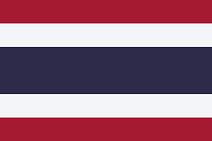Country: Thailand
Committee: WHO
Topic: New normal after Covid 19 and the role of vaccination.

As the first country to identify a case of Covid-19, outside of China, Thailand has been a forerunner in the detection of the virus. Our strategic investment in the health system of the country ultimately enabled a quick and effective response to the Covid 19 virus. On January 10, anticipating what would happen, the Royal Thai Government (RTG) started a nation-wide public communication campaign to provide accurate information about Covid-19.
Since 2020, The Ministry of Public Health (MoPH) has been working tirelessly to implement measures to reduce the number of cases of the virus. The newly created Centre for Covid-19 Situation Administration, under the direct leadership of the Prime Minister, established measures to contain the virus and keep our citizens safe. Laboratory and research capacity are also part of Thailand’s strong health system. The Thai Red Cross Emerging Infectious Diseases-Health Science Centre in Chulalongkorn University (a WHO Collaborating Centre) has researched viruses and diseases for over twenty years.
In Thailand, the mood is optimistic but cautious. Thai public health authorities are actively preparing for further outbreaks of locally transmitted Covid-19 and are encouraging the population to continue to comply with basic public health measures including mask-wearing and physical distancing.
We are committed to the Covid-19 Vaccination Programme and after some unavoidable setbacks we are on course to vaccinate the population as quickly as possible. As of March 2022, we have administered 124 Million doses of the vaccine resulting in 71% of the population being safely innoculated.
Thailand will continue to work with the World Health Organisation (WHO) and follow their directorate to keep the spread of Covid-19 to the minimum nuber as possible.

