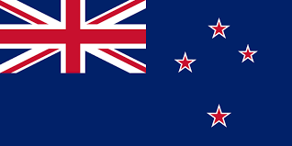Country: New Zealand.
Committee: WHO
Agenda Topic: New normal after Covid-19 and the role of vaccinations.
From the beginning of the Covid-19 pandemic, New Zealand took a proactive position by closing our borders in a bid to contain the threat of the virus. We imposed strict lockdown rules to safeguard our population and that of the global community at large. Our “zero-Covid” approach was deemed necessary and proved to be highly effective. Prime Minister Jacinda Ardern considered the public health system and the pressures that it would sustain due to the Covid pandemic. New Zealand has been cooperating with the WHO mandates and supports all initiatives and guidelines regarding Covid 19.
The focus of our policy was that of both the health and economic well-being of the population. As of 22nd March 2022, 94% of the citizens of New Zealand are fully vaccinated. We have made it our main goal to work with all UN agencies to provide access and information about Covid 19 vaccinations. We have worked with government and community sectors to ensure that all relevant information is provided and recieved by those most in need. We have commissioned crucial laboratory and medical supplies to test and treat cases of Covid 19.
As the threat of the Covid 19 pandemic subsides, we continue to be committed to following the guidelines and mandates that regulate the ongoing initiative to eradicate the virus. New Zealand has pledged to ensure all citizens are vaccinated and given full access to boosters as we move forward towards a safer environment. We will keep in line with UN member states to slowly reduce the risk of a second wave pandemic situation.
We aim to work together with the UN, WHO and all relevant agencies to continue to reduce restrictions and secure a virus free World. New Zealand’s goal is to allow its citizens to return to life without risk and to provide a healthier society that is economically and socially stronger.

