ANKAMUN’21
Committee: UNODC Country: Mexico 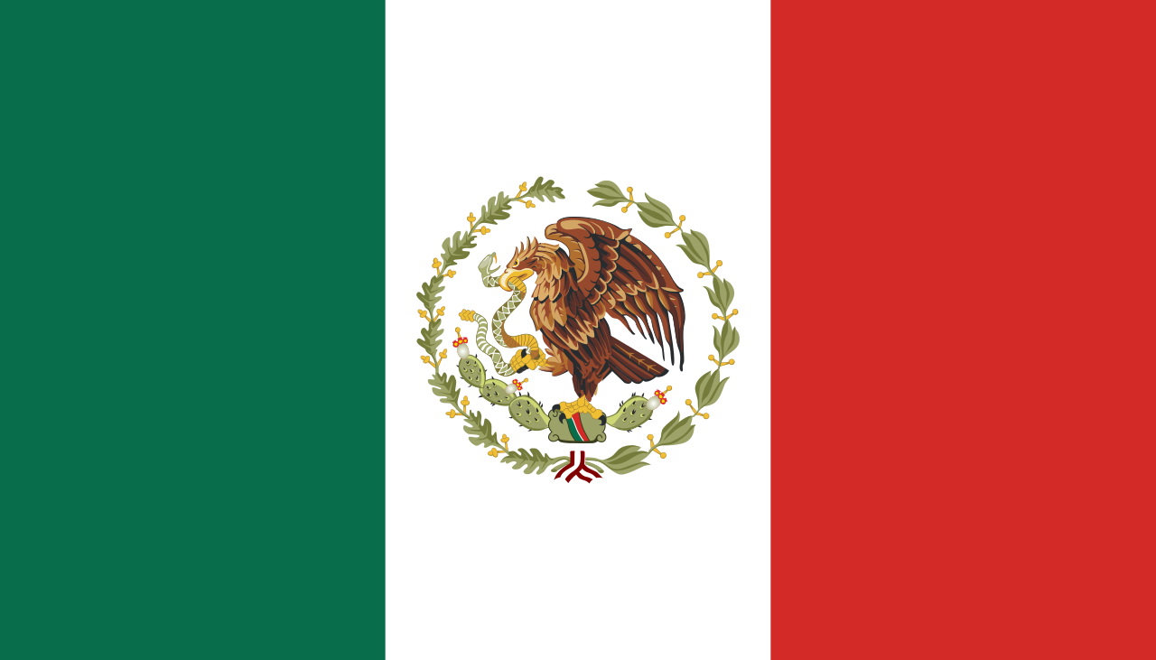
Agenda item: The Usage of Appearance and Performance Enhancing Drugs (APEDs) and Sports
Mexico is a country in southern North America, with extensive coastlines on the Gulf of Mexico and the Pacific Ocean. In the north there is a 3,169 km (1,969 mi) long border separating Mexico and the United States. Mexico is also bordered by Guatemala, and Belize and it shares maritime borders with Cuba and Honduras.Mexico has an population of 127.6 million and of the 90,343,542 adult urban population of Mexico, 10.4% of them (representing 5.2 million people in total) had used illicit substances at some point in their lifetime, with the rate for males being about five times the rate for females in 1990s.

Appearance and performance enhancing drugs (APEDs) are most often used by males to improve appearance by building muscle mass or to enhance athletic performance. The percentage of Mexican men between 12 and 65 who have used illegal drugs nearly doubled over the past decade (to 15.8 percent) while the percentage of women more than doubled (to 4.3 percent), according to the latest national survey. Males who are more likely to use steroids tend to have poor self-esteem, higher rates of depression, more suicide attempts, poor knowledge and attitudes about health, greater participation in sports emphasizing weight and shape, greater parental concern about weight, and higher rates of eating disorders and substance use. Even some people who misuse steroids have experienced physical or sexual abuse. In a study of 506 male users and 771 male nonusers of anabolic steroids, users were significantly more likely than nonusers to report being sexually abused in the past In order to stop this, most countries banned the usage of steroids for the olympics.

At Rome Olympics in 1960 Danish cyclist (Knud Jensen) died. It was the first death of an athlete during Olympic competition. His death is remembered as the beginning of the Olympic anti-doping movement. Doping is now a global problem that follows international sporting events worldwide. International sports federations, led by the International Olympic Committee, have for the past half century attempted to stop the spread of this problem, with little effect. However, new, more powerful and undetectable doping techniques and substances are now abused by professional athletes.

With the help of WADA and UNODC, the tests which are done before the competitons can can With the cooperation of the every country, or at least the countries with high usage of Drugs, major amount of Drug Activities can be slowed down and therefore precious lifes will be saved by doing restrictions, giving high amounts of punishments to the athletes who are using APEDs and they can be identified by tests which will be done before the competitons and olympics...

