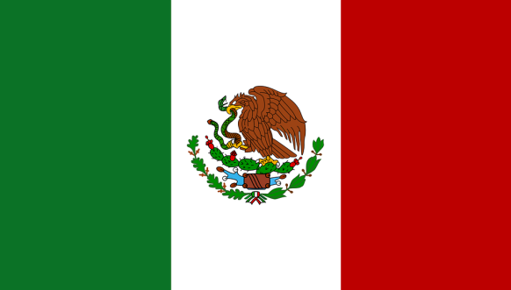
COUNTRY: United Mexican States (Mexico)
COMMITTEE: Disarmament and International Security (DISEC)
TOPIC AREA: Proliferation of Nuclear Weapons

Nuclear proliferation is the spread of nuclear weapons, fissionable material, and weapons-applicable nuclear technology and information to nations not recognized as "Nuclear Weapon States" by the Treaty on the Non-Proliferation of Nuclear Weapons, commonly known as the Non-Proliferation Treaty or NPT. Proliferation has been opposed by many nations with and without nuclear weapons, as governments fear that more countries with nuclear weapons will increase the possibility of nuclear warfare, de-stabilize international or regional relations, or infringe upon the national sovereignty of nation states.

Current Policy
Mexico is one of the few countries which has technical capabilities to manufacture nuclear weapons. However it has renounced them and pledged to only use its nuclear technology for peaceful purposes following the Treaty of Tlatelolco (also known as The Latin America Nuclear Weapons Free Zone Treaty) in 1968.
In the 1970s Mexico's national institute for nuclear research successfully achieved the creation of highly enriched uranium which is used in nuclear power plants and in the construction of nuclear weapons. However the country agreed in 2012 to downgrade the high enriched uranium used on its nuclear power plants to low enriched uranium, the process was realised with the assistance of the International Atomic Energy Agency. It is unknown if Mexico ever created or possessed nuclear or any other kind of mass destruction weapons.

Solution
Nuclear disarmament should be pursued in a clear way by all nuclear-weapon States. Additionally, monitoring systems should be improved for all civilian nuclear activities, without further discrimination with respect to those that are already within the NPT. The development of nuclear energy should happen in a framework that must guarantee and strengthen security for all and foster a sense of collective responsibility. Nuclear weapons should soon be declared illegal as much as all the other chemical and biological weapons of mass destruction are. This will require a nuclear weapons convention similar to the chemical and biological weapons convention. Countries should clearly and unequivocally do their best to signal that they are moving in that direction.

