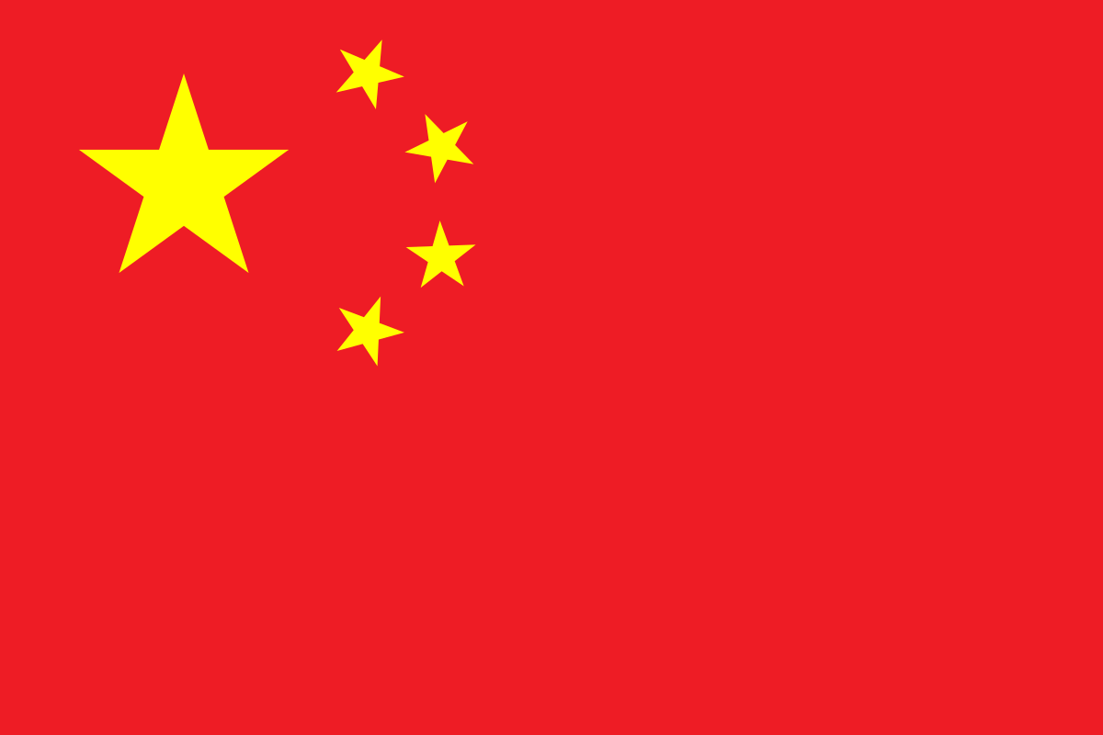

COMMITTEE: UNICEF

COUNTRY: CHINA

AGENDA ITEM: ASSESING THE CURRENT SITUATION OF CHILD LABOR

China is a country in East Asia. It is the world's [second most populous country](https://en.wikipedia.org/wiki/List_of_countries_by_population_(United_Nations)" \o "List of countries by population (United Nations)), with [a population](https://en.wikipedia.org/wiki/Population_of_China) more than 1.4 billion. it is the third-largest country by total land area with a nearly 9.6 million square kilometers area. China has 33 administrative units directly under the central government; these consist of 22 provinces, 5 autonomous regions, 4 municipalities and 2 special administrative regions.

China is commited eliminate child labor. China has ratified the Minimum Age Convention and the Worst Forms of Child Labour Convention. Chinese authorities at various levels have implemented measures to ensure that child victims of chil labor have access to social services, compulsory education and quality education programme. Since 1949, the new government have been reforming the education system and getting children out of their works and back into school.Reaching more children, teaching our citizents and every people all across the World the importance of this issue is our role. Our childrens health and well-being is our priority.

China is aware of the importance of this problem and ready to act in favor of preventing this issue. China is willing to help other countries to save our children, our future.

**SOURCES**

• <https://china.un.org/en/sdgs/8>

•<https://violenceagainstchildren.un.org/content/Child%20Labour>

• <https://www.britannica.com/place/China>

• <https://clb.org.hk/en/content/child-labour-china>

•<https://en.wikipedia.org/wiki/China>

• <https://www.ilo.org/beijing/areas-of-work/child-labour/lang--en/index.htm>