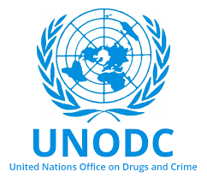

Country :Canada COMMITTEE:UNDOC
AGENDA ITEM : MONEY LAUNDERING AND COUNTERING THE FINANCING OF TERRORISM
Canada’s anti-money laundering and terrorist financing laws are primarily contained in two
statutes: the Criminal Code and the Proceeds of Crime (Money Laundering) and Terrorist
Financing Act The Criminal Code applies to all individuals and businesses. Under the
Criminal Code, it is an offence to knowingly deal with any property or provide or facilitate
any financial or related service for any terrorist activity or any terrorist group or “listed
person” (a person or entity on a government or other agency list).

Anti money laundering assessed and The average country risk level has been deteriorating
over the Last three years . The delegate of canada is really concernad about the Situation
Because it has effects in canada. The delegate of canada believes that we should prevent those
actions such as terrorism, money laundering, illicit drug sellings. İn canada selling drugs are
legal with municipal supervision so it prevents the illicit drug sellerss Gain and also To
prevent children from using drugs.To prevent money laundering The delegate of canada
thinks there can be special Military team for anonymus payment systems Because Polices cant
reach People Personal information so only those People Will be able to reach Personal
information and Information about money laundering and it Will be easy to Determine them.
İn conclusion money laundering and financing terrorism have a huge impact on earth and not
only about money also it have a huge place in social cultural humanitarian impact
. Elif özdemir
References
mun point UNODC study guide
https://www.osler.com/en/resources/business-in-canada/browse-topics/additional/anti-money-laundering-and-terrorist-financing
https://laws-lois.justice.gc.ca/eng/acts/p-24.501/page-1.html

